SIMATS ENGINEERING
CSA0928 – Programming in Java
ASSIGNMENT 3 – REPORT
Exception Handling and Multithreading (CO3) · Pair work · 50 marks

Item | Details Student A | Details Student B
Student name | RAKSHITH R.R | RAKSHITH R.R
Register number | 192324156 | 192324156
Department / Section | B.Tech -AI&DS | B.Tech -AI&DS
Java version used | OpenJDK 21 | OpenJDK 21
GitHub repository link | 192324156---RAKSHITH-R.R---CSA0928---PROGRAMMING-IN-JAVA/ASSIGNMENT - 3 at main · RAKS-rak57/192324156---RAKSHITH-R.R---CSA0928---PROGRAMMING-IN-JAVA | 192324156---RAKSHITH-R.R---CSA0928---PROGRAMMING-IN-JAVA/ASSIGNMENT - 3 at main · RAKS-rak57/192324156---RAKSHITH-R.R---CSA0928---PROGRAMMING-IN-JAVA
Submission date | 12/11/2026 | 12/11/2026

Placeholders in [ ] must be filled in before submission. The assignment document is reproduced on the preceding pages; the answers follow. Each individual section is labelled Student A or Student B; both students executed every program.

Individual Contribution Record
The primary responsibilities below are exactly those defined in the assignment for each question. Both students ran, tested and can defend every question.

Question | Student A – primary responsibility | Student B – primary responsibility | Joint
Q1 | Exception design: Throwable hierarchy, failure → exception table, catch order, role of finally | Testing and tracing: test inputs, catch/finally record, stack trace of an uncaught exception, broad-before-narrow demonstration | Failure points, classification, implementation, testing; the catch (Exception) question; error-code alternative
Q2 | Class diagram of the exception hierarchy, checked/unchecked reasons, propagation path, final handling and message | One scenario per exception, chaining with getCause(), full chained trace, what is lost without the cause, test table | Hierarchy, throw/throws across three layers, chaining; conclusion; StorageDemo
Q3 | Debugging (breakpoints, step-through), failing input, open-file count per version, logging | Resources and where they must be closed, why manual leaks, try-with-resources guarantee and order, suppressed exceptions | Manual and try-with-resources versions, same report; engineering decision; alternative analysis
Q4 | Thread vs Runnable, life-cycle diagram, run() vs start() evidence, join() explanation | 12+ runs, priorities, daemon thread, scheduler explanation | Both implementations; conclusion; executor analysis
Q5 | Reliable test for double booking, count over repeated runs, step-by-step interleaving, critical section | Timing of 10,000 bookings, lock scope, static synchronization, intrinsic locks | Three versions; decision for 20 screens; SeatBooking; alternatives
Q6 | Producer–consumer: wait() in a loop, notify() vs notifyAll(), counter size trace, sleep() vs wait() | Reliable deadlock, four conditions, lock-ordering prevention and why it works | Both parts; TokenCounter; conclusion; ArrayBlockingQueue/tryLock analysis
Q7 | Stage 2 – design: executor/Callable/Future, concurrent collection, exception design, class diagram, pseudocode | Stage 3 – implementation, fault injection, timing with 1/2/4/8 threads, hand-checked set, unhandled failure | Stage 1 – interpretation; Stage 4 – defence; alternative analysis

Execution Environment and How the Measurements Were Taken
Item | Value
Java | OpenJDK 21.0.12 (HotSpot), compiled with javac -g
Machine used for the recorded outputs | Linux container, 1 CPU core (availableProcessors() = 1), default thread stack 1,024 KB, default ulimit -n 20,000
Timing method | System.nanoTime(); warm-up runs first (JIT); best or median of repeated runs as stated in each table
Raw data | Every program's output is saved in Qn/output/*.txt (and as screenshots); Q7/output/measurements.csv holds every timed Q7 run; charts are in docs/charts
Important limitation | With one core, CPU-bound programs cannot run in parallel, so speed-ups from threads appear only when threads wait (sleep or I/O). Race conditions that need true parallelism were reproduced by widening the window with Thread.yield(), and this is stated wherever it was done. All timing experiments should be re-run on a multi-core computer (./run_all.sh) and the tables compared; the conclusions about lock scope, space and complexity do not depend on the number of cores.

Summary of results
Q | Marks | Headline result
1 | 6 | 12/12 ATM tests; finally ran on all 12 paths; exception ≈ 130× slower than an error code per failing input but equal on success
2 | 7 | StorageDemo matches the expected output; 8/8 portal scenarios; chaining doubles trace time/memory (≈ 2×)
3 | 7 | Leaky version leaves 2 handles open and a 0-byte report; manual finally and try-with-resources leave 0; "Too many open files" reproduced
4 | 7 | 24 recorded runs, different order each time, total always 80; pool follows the n/p model (efficiency 0.97 at p = 8)
5 | 6 | Seats sold: 10; natural race not seen in 10 runs, 2,498/2,500 double bookings with the window widened; block lock 8× faster than method lock with a 100 µs payment step
6 | 7 | Sum … 210; if gave a wrong sum in 8/10 runs; notify() hung 10/10 with several producers; deadlock detected and prevented by lock ordering
7 | 10 | Summary correct for 15 hand-checked and 10,000 generated files at every pool size; defect found and fixed; near-linear speed-up (31.8× at 32 threads) for latency-bound work

Q1 – Handling Failure in a Bank ATM Simulation (6 marks, K4)

Shared group work – failure points, classification, implementation, testing
Every point at which a withdrawal can fail was identified by walking through the steps of the withdrawal (read account → read amount → validate → open card-reader file → find account → compare balance → dispense). The classification follows the Java rule: an Error signals a JVM problem the program cannot repair; a checked exception is an expected, recoverable condition that the compiler forces the caller to handle or declare; an unchecked exception (RuntimeException) is a defect or invalid argument that the caller could have avoided.
import java.io.BufferedReader;
import java.io.FileNotFoundException;
import java.io.FileReader;
import java.io.IOException;
import java.util.InputMismatchException;
import java.util.NoSuchElementException;
import java.util.Scanner;

/** Q1 - ATM withdrawal with try / catch (incl. multi-catch) / finally. */
public class Atm {
static int finallyRuns = 0; // how many times a finally block has executed

/** Returns the PATH taken (SUCCESS or the name of the failure) so that tests can check it. */
static String withdraw(String request, String cardFile) {
BufferedReader reader = null;
String path = "SUCCESS";
try {
Scanner in = new Scanner(request);
int account = in.nextInt(); // letters -> InputMismatchException (unchecked)
int amount = in.nextInt(); // missing token-> NoSuchElementException (unchecked)
if (amount <= 0) // negative / zero -> our own unchecked failure
throw new IllegalArgumentException("Amount must be positive: " + amount);
reader = new BufferedReader(new FileReader(cardFile)); // missing file -> FileNotFoundException (checked)
int balance = findBalance(reader, account); // IOException, AccountNotFound, CardData (checked)
if (amount > balance) throw new InsufficientFundsException(balance, amount);
System.out.println(" dispensed " + amount + ", new balance " + (balance - amount));

} catch (InputMismatchException | IllegalArgumentException e) { // MULTI-CATCH: two unrelated types, same handling
path = "BAD_INPUT";
System.out.println(" Please enter a valid account number and a positive amount (" + e.getClass().getSimpleName() + ")");
} catch (NoSuchElementException e) { // superclass of InputMismatchException: must come AFTER it
path = "MISSING_INPUT";
System.out.println(" Please enter both the account number and the amount");
} catch (InsufficientFundsException e) {
path = "INSUFFICIENT_FUNDS";
System.out.println(" " + e.getMessage() + " (short by " + e.getShortfall() + ")");
} catch (AccountNotFoundException e) {
path = "ACCOUNT_NOT_FOUND";
System.out.println(" " + e.getMessage());
} catch (CardDataException e) {
path = "CARD_DATA";
System.out.println(" Card data damaged: " + e.getMessage() + " [cause: " + e.getCause().getClass().getSimpleName() + "]");
} catch (FileNotFoundException e) { // subclass of IOException: must come BEFORE it
path = "CARD_FILE_MISSING";
System.out.println(" Card reader unavailable: " + cardFile);
} catch (IOException e) {
path = "IO_ERROR";
System.out.println(" Card reader error: " + e.getMessage());
} catch (Exception e) { // last-resort safety net, AFTER every specific handler
path = "UNEXPECTED";
System.out.println(" Unexpected problem, transaction cancelled: " + e);
} finally {
finallyRuns++; // runs on EVERY path: success, handled failure, even return
System.out.println(" [finally] card reader released, session closed");
if (reader != null) {
try { reader.close(); } catch (IOException ignored) { }
}
}
return path;
}

private static int findBalance(BufferedReader r, int account)
throws IOException, AccountNotFoundException, CardDataException {
String line;
while ((line = r.readLine()) != null) {
String[] p = line.split(",");
try {
if (Integer.parseInt(p[0].trim()) == account) return Integer.parseInt(p[1].trim());
} catch (NumberFormatException | ArrayIndexOutOfBoundsException e) {
throw new CardDataException("bad line \"" + line + "\"", e); // wrap: file damage is not the user's mistake
}
}
throw new AccountNotFoundException(account);
}
}

Student A – Exception design

A1. Part of the Throwable hierarchy used by the ATM
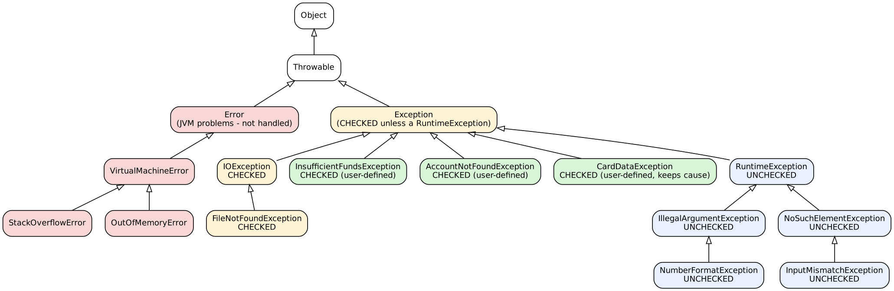
Figure Q1.1 – Throwable hierarchy relevant to the ATM (red = Error, yellow = checked, blue = unchecked, green = user-defined checked). The superclass chains were also printed by ErrorDemo (Q1/output).

A2. Failure point → exception type → checked / unchecked → where it is caught
# | Failure point | Exception type | Checked? | Caught in (Atm.withdraw)
1 | Letters typed for the account number or amount (nextInt()) | InputMismatchException | Unchecked | catch 1 – multi-catch InputMismatchException \| IllegalArgumentException → BAD_INPUT
2 | Negative or zero amount | IllegalArgumentException (thrown by the program) | Unchecked | catch 1 – same multi-catch
3 | Amount missing (only one token typed) | NoSuchElementException | Unchecked | catch 2 → MISSING_INPUT
4 | More than the balance | InsufficientFundsException (user-defined) | Checked | catch 3 → INSUFFICIENT_FUNDS
5 | Account number not in the card file | AccountNotFoundException (user-defined) | Checked | catch 4 → ACCOUNT_NOT_FOUND
6 | Card-file line damaged (Integer.parseInt fails) | NumberFormatException wrapped in CardDataException (cause kept) | Checked (wrapper) | catch 5 → CARD_DATA
7 | Card-reader file missing (or a directory) | FileNotFoundException | Checked | catch 6 → CARD_FILE_MISSING
8 | Read error while reading the card file | IOException | Checked | catch 7 → IO_ERROR
9 | A bug in the ATM code (e.g. null reference) | RuntimeException subclasses | Unchecked | catch 8 Exception – last resort → UNEXPECTED
10 | JVM out of memory / stack overflow while dispensing | OutOfMemoryError, StackOverflowError | Error | Not caught. ErrorDemo shows catch (Exception) does not catch a StackOverflowError; only the JVM's top level reports it.

Row 6 is a design decision: NumberFormatException is *unchecked*, but when it is raised while reading the card file it is not the customer's mistake. If it escaped unchanged it would be caught by the multi-catch of row 1 and the customer would be told "enter a valid amount" for a damaged card. It is therefore wrapped in the checked CardDataException, keeping the original as the cause (see the CARD_DATA test below).

A3. Justification of the order of the catch blocks
Java tests the catch blocks from top to bottom and runs the first one whose type matches, so a subclass must appear before its superclass (the compiler rejects the opposite order – see Student B). The order used:
- InputMismatchException | IllegalArgumentException – the user-input failures; unrelated types, so a multi-catch is legal and avoids duplicating the handler.
- NoSuchElementException – superclass of InputMismatchException; it had to come after catch 1, otherwise catch 1's InputMismatchException would be unreachable.
- InsufficientFundsException, AccountNotFoundException, CardDataException – unrelated business failures, each with its own message.
- FileNotFoundException – subclass of IOException, so it precedes IOException.
- IOException – all remaining I/O failures.
- Exception – last resort only, after every specific handler.

A4. What finally guarantees in this program
The finally block runs on every path out of the try: normal completion, any handled exception, and even a return or an exception thrown from inside a catch block. In the ATM it increments finallyRuns, prints "card reader released, session closed", and closes the BufferedReader (inside its own try/catch because close() can throw). The test table below shows it executed for all 12 inputs. What it does not guarantee: it will not run if the JVM is terminated (System.exit, power loss) or the thread is killed, and an exception thrown *from* the finally block would replace the original one.

Student B – Testing and tracing

B1. Test inputs – the catch block taken and whether finally ran
AtmTest reads Q1/input/tests.txt and checks both the path and that finally executed exactly once per call.
# | Test | Request | Card file | Expected path (catch) | Actual path | finally ran | Result
1 | valid withdrawal | 1001 500 | cards.txt | SUCCESS | SUCCESS | yes | PASS
2 | exact balance (boundary) | 1002 200 | cards.txt | SUCCESS | SUCCESS | yes | PASS
3 | letters instead of number | abc 500 | cards.txt | BAD_INPUT | BAD_INPUT | yes | PASS
4 | letters in the amount | 1001 five | cards.txt | BAD_INPUT | BAD_INPUT | yes | PASS
5 | negative amount | 1001 -50 | cards.txt | BAD_INPUT | BAD_INPUT | yes | PASS
6 | zero amount | 1001 0 | cards.txt | BAD_INPUT | BAD_INPUT | yes | PASS
7 | amount token missing | 1001 | cards.txt | MISSING_INPUT | MISSING_INPUT | yes | PASS
8 | more than the balance | 1002 900 | cards.txt | INSUFFICIENT_FUNDS | INSUFFICIENT_FUNDS | yes | PASS
9 | unknown account | 9999 100 | cards.txt | ACCOUNT_NOT_FOUND | ACCOUNT_NOT_FOUND | yes | PASS
10 | card file missing | 1001 100 | no_such_file.txt | CARD_FILE_MISSING | CARD_FILE_MISSING | yes | PASS
11 | card file damaged | 1002 100 | cards_corrupt.txt | CARD_DATA | CARD_DATA | yes | PASS
12 | card path is a directory | 1001 100 | input | CARD_FILE_MISSING | CARD_FILE_MISSING | yes | PASS

Result: 12 / 12 tests passed and 12 finally blocks executed (Q1/output/AtmTest.txt). A correction recorded honestly: my first expectation for test 12 (path that is a directory) was IO_ERROR. The run showed CARD_FILE_MISSING – FileReader reports a directory as FileNotFoundException ("Is a directory"). The expected value in tests.txt was corrected; the program was right.
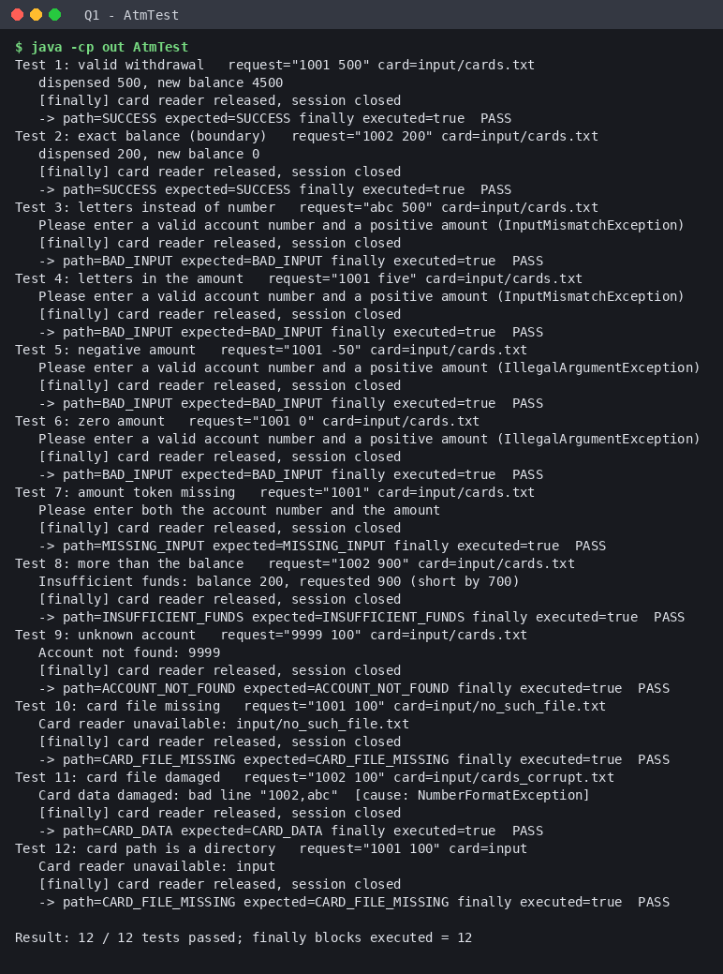
Figure Q1.2 – Output of AtmTest (first 50 lines)

B2. Stack trace of an uncaught exception, line by line
$ java -cp out UncaughtDemo 2>&1; echo "exit code = $?"
ATM started
Exception in thread "main" java.lang.NumberFormatException: For input string: "abc"
at java.base/java.lang.NumberFormatException.forInputString(NumberFormatException.java:67)
at java.base/java.lang.Integer.parseInt(Integer.java:662)
at java.base/java.lang.Integer.parseInt(Integer.java:778)
at UncaughtDemo.parseAmount(UncaughtDemo.java:13)
at UncaughtDemo.process(UncaughtDemo.java:9)
at UncaughtDemo.main(UncaughtDemo.java:5)
exit code = 1

Line of the trace | Meaning
Exception in thread "main" java.lang.NumberFormatException: For input string: "abc" | Which thread died, the exception class and its message (the text that could not be converted).
at java.base/java.lang.NumberFormatException.forInputString(...) | Top of the stack = where the exception was created (inside the JDK).
at java.base/java.lang.Integer.parseInt(...) (two lines) | The JDK method that detected the bad text and threw.
at UncaughtDemo.parseAmount(UncaughtDemo.java:13) | Our code that called parseInt – the first line that belongs to the program (where to start debugging).
at UncaughtDemo.process(UncaughtDemo.java:9) | The caller of parseAmount; no try/catch, so the exception kept travelling up.
at UncaughtDemo.main(UncaughtDemo.java:5) | Bottom of the stack: where the program started. No handler anywhere, so the JVM printed the trace and ended the thread.
exit code = 1 | The process ended abnormally; "this line is never printed" shows execution never returned to main.

B3. A broader catch block placed before a narrower one
import java.io.*;
public class BroadBeforeNarrow {
public static void main(String[] a) {
try { new FileReader("x.txt").close(); }
catch (Exception e) { System.out.println("any exception"); } // broad handler first
catch (FileNotFoundException e) { System.out.println("file missing"); } // can never be reached
}
}

$ for f in negative/*.java; do echo "### javac $f"; javac -d /tmp/neg $f 2>&1; done
### javac negative/BroadBeforeNarrow.java
negative/BroadBeforeNarrow.java:6: error: exception FileNotFoundException has already been caught
catch (FileNotFoundException e) { System.out.println("file missing"); } // can never be reached
^
1 error
### javac negative/MultiCatchRelated.java
negative/MultiCatchRelated.java:4: error: Alternatives in a multi-catch statement cannot be related by subclassing
catch (NumberFormatException | IllegalArgumentException e) { } // NumberFormatException IS-A IllegalArgumentException
^
1 error
### javac negative/UnreportedChecked.java
negative/UnreportedChecked.java:4: error: unreported exception FileNotFoundException; must be caught or declared to be thrown
^

The compiler refuses to compile it: exception FileNotFoundException has already been caught. The broad catch (Exception) would take every exception first, so the narrow handler could never run. The same output shows the other two related compile-time rules that the ATM relies on: a multi-catch whose alternatives are related by subclassing is rejected, and a checked exception that is neither caught nor declared is rejected.

Joint design question – should the ATM catch everything with one catch (Exception e)?
No, not as the only handler. It is acceptable only in two situations: (1) as the last handler at a program boundary (the catch (Exception) of withdraw), after every specific handler, so that an unforeseen bug cancels the transaction safely instead of crashing the ATM and the card is still released; (2) when the failure is logged with its stack trace and nothing else can sensibly be done. What is lost: the ability to give the customer the right message ("insufficient funds" and "card reader unavailable" need different responses and different recovery); the compiler's help (checked exceptions you forgot to think about disappear into the catch-all); the distinction between customer mistakes, system faults and bugs; and, if the handler is empty or only prints, the evidence needed to find a defect (a NullPointerException becomes indistinguishable from a bad amount). It also swallows InterruptedException and similar signals that should be propagated.

Alternative Concept and Complexity Analysis – no exceptions, error codes
What the solution would be. Every input is validated before use (Scanner.hasNextInt(), amount > 0, file exists, account found, balance sufficient) and each method returns a code (0 success, -1 bad input, -2 negative amount, -3 file missing, -4 account not found, -5 insufficient funds, -6 damaged data). The caller tests the code after every call.
int code = withdrawCode(request, cardFile);
if (code == -1) System.out.println("Enter valid numbers");
else if (code == -2) System.out.println("Amount must be positive");
else if (code == -3) System.out.println("Card reader unavailable");
else if (code == -4) ... else if (code == -5) ... else if (code == -6) ... else dispense();

static int withdrawCode(String request, String file) {
Scanner in = new Scanner(request);
if (!in.hasNextInt()) return -1; int account = in.nextInt();
if (!in.hasNextInt()) return -1; int amount = in.nextInt();
if (amount <= 0) return -2;
if (!new java.io.File(file).exists()) return -3; // still needs try/catch for IOException: the file can vanish after the check
...

Criterion | Exceptions (implemented) | Error codes
Readability | Normal path reads top to bottom; each failure has its own handler with a name | Every call is followed by an if (code == ...); the useful path is buried; magic numbers must be documented
Number of checks | One try + 8 catch blocks; the failing statement itself raises the problem – no pre-checks | At least 6 explicit tests before/after the calls (hasNextInt ×2, amount, file exists, account found, balance) plus the caller's if/else chain on the code plus a try/catch anyway for IOException, which Java still forces
Safety | A forgotten failure cannot be silently ignored (checked) or at least stops the program (unchecked) | A forgotten if (code ...) silently continues with bad data; a time-of-check/time-of-use gap (file deleted after exists())
Failure information | Type, message, stack trace, cause chain | One integer

Time and space cost (measured by ExceptionCostBenchmark, results in Q1/output and Figure Q1.3):
Share of invalid inputs | try / catch (ns per input) | check first + error code (ns per input)
0 % | 4.4 | 5.9
1 % | 13.0 | 16.3
10 % | 50.5 | 15.6
50 % | 200.4 | 15.1
100 % | 362.5 | 2.8

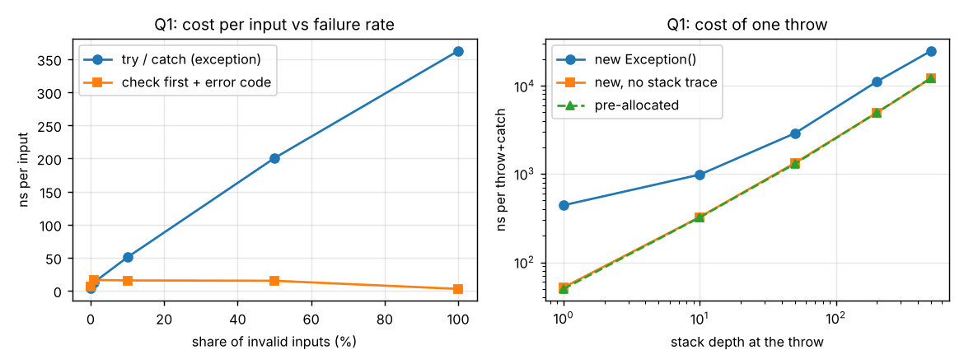
Figure Q1.3 – Left: cost per input vs share of invalid inputs. Right: cost of one throw by stack depth (log–log).
Analysis. On the success path an exception costs nothing extra (4.4 ns versus 5.9 ns for the extra pre-check – the check is even slightly slower). Each failure costs a lot: creating the exception fills in its stack trace, which walks the call stack, so the cost of one throw grows with the stack depth – Θ(d) (442 ns at depth 1, 24,676 ns at depth 500; the table in ExceptionCostBenchmark.txt). At 100 % invalid input the exception version is about 130× slower per input (362 ns versus 2.8 ns). Part of that cost is only the stack trace: an exception created without a stack trace is 3–8× cheaper, but it still grows with depth because unwinding the frames is also Θ(d). Space: an exception object holds its stack trace – about 724 bytes at depth 1, 2,796 bytes at depth 100, and 8,116 bytes once getStackTrace() has expanded it to StackTraceElement objects (Θ(d)); an error code is a 4-byte int, Θ(1). Conclusion: exceptions are the right tool for *exceptional* conditions; at the ATM's rate (a few invalid entries per minute) the microseconds are irrelevant, while the readability and safety advantages are decisive. Error codes would be preferred only in a hot loop where most inputs are expected to be invalid.

Q2 – User-Defined Exceptions and Propagation in an Online Examination Portal (7 marks, K4)

Shared group work – hierarchy, checked/unchecked decision, three layers, chaining
The portal has three layers in package portal: ExamController (talks to the student), SubmissionService (business rules) and Storage (disk). Rules checked, in order: the arguments are valid → the student is registered → the exam window is open → the file is within 200 KB → the storage accepts it (total quota 500 KB).
package portal;
import java.time.LocalDateTime;
import java.util.Map;
import java.util.Set;
/** SERVICE layer: business rules. Declares (throws) what it cannot handle and lets it propagate upwards. */
public class SubmissionService {
static final long SIZE_LIMIT_KB = 200;
private final Map<String, Set<String>> registrations; // course -> registered students
private final Map<String, LocalDateTime> windowCloses; // course -> deadline
private final Storage storage;
private final boolean lossy;

public SubmissionService(Map<String, Set<String>> registrations, Map<String, LocalDateTime> windowCloses, Storage storage, boolean lossy) {
this.registrations = registrations; this.windowCloses = windowCloses; this.storage = storage; this.lossy = lossy;
}
public void submit(String student, String course, String fileName, long sizeKb, LocalDateTime now) throws ExamException {
if (student == null || student.isBlank() || fileName == null || fileName.isBlank() || sizeKb < 0)
throw new InvalidSubmissionException("student, file name and a non-negative size are required"); // unchecked
if (!registrations.getOrDefault(course, Set.of()).contains(student))
throw new NotRegisteredException(student, course);
LocalDateTime closes = windowCloses.get(course);
if (closes == null || now.isAfter(closes))
throw new ExamWindowClosedException(closes, now);
if (sizeKb > SIZE_LIMIT_KB)
throw new FileTooLargeException(fileName, sizeKb, SIZE_LIMIT_KB);
if (lossy) storage.saveLossy(fileName, sizeKb); else storage.save(fileName, sizeKb); // SubmissionStorageException propagates
}
}

package portal;
import java.io.IOException;
/** STORAGE layer: the only layer that knows about disks. Total disk quota 500 KB. */
public class Storage {
private long usedKb = 0;
private final long quotaKb = 500;
public void save(String fileName, long sizeKb) throws SubmissionStorageException {
try {
if (usedKb + sizeKb > quotaKb) throw new IOException("Disk quota exceeded"); // the low-level failure
usedKb += sizeKb;
} catch (IOException e) {
throw new SubmissionStorageException("Could not store " + fileName, e); // wrap, keep the cause
}
}
/** Same failure, but the cause is thrown away (used to show what chaining protects). */
public void saveLossy(String fileName, long sizeKb) throws SubmissionStorageException {
try {
if (usedKb + sizeKb > quotaKb) throw new IOException("Disk quota exceeded");
usedKb += sizeKb;
} catch (IOException e) {
throw new SubmissionStorageException("Could not store " + fileName); // cause LOST
}
}
}

Student A – Exception hierarchy and propagation design

A1. Class diagram of the exception hierarchy
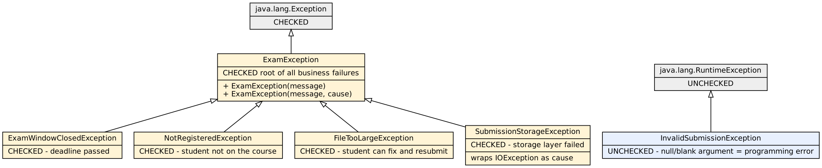
Figure Q2.1 – Exception hierarchy of the portal

A2. Why each exception is checked or unchecked
Exception | Kind | Reason
ExamException (root) | Checked | Gives the controller one type to catch for "a business rule or the storage failed" and forces every layer to decide what to do.
ExamWindowClosedException | Checked | An expected business event, not a bug. The student cannot fix it, but the caller must produce a proper message – the compiler should force that.
NotRegisteredException | Checked | Expected rejection that depends on data, not on a programming mistake.
FileTooLargeException | Checked | Recoverable: the student can compress the file and resubmit, so callers must handle it.
SubmissionStorageException | Checked | An environment failure (disk) that the controller can translate to "try again"; it wraps the IOException so the cause is kept.
InvalidSubmissionException | Unchecked (RuntimeException) | A blank student/file name is a programming error of the caller. Nobody can recover from it at run time, so it should not clutter every signature; it is fixed by correcting the code.

A3. Propagation path of one exception (storage → controller)
Figure Q2.2 – Path of a disk-quota failure through the three layers
Where it is finally handled and what the student sees: the IOException is caught in Storage.save, wrapped into a SubmissionStorageException (cause kept), and propagates through SubmissionService.submit (which only *declares* throws ExamException) to ExamController.submit, which has catch (SubmissionStorageException e). The controller is the correct place because it is the layer that talks to the student and can choose the wording. The student sees: *"ERROR: we could not save your answer, please try again (reference logged)"* – no stack trace, no file-system detail. The original Disk quota exceeded stays available through getCause() for the log.

Student B – Failure scenarios and chaining evidence

B1. One scenario per exception – test table (observed behaviour)
# | Scenario | Exception that reached the controller | Message shown to the student | Result
1 | valid submission | none | OK: ans1.pdf submitted | PASS
2 | student not registered | NotRegisteredException | REJECTED: you are not registered for CSA0928 | PASS
3 | window closed (12:01) | ExamWindowClosedException | REJECTED: the exam window has closed | PASS
4 | exactly at closing time (boundary) | none | OK: ans3b.pdf submitted | PASS
5 | file too large (201 KB) | FileTooLargeException | REJECTED: your file is larger than 200 KB - please compress it | PASS
6 | file exactly at the limit (200 KB) | none | OK: ans4b.pdf submitted | PASS
7 | disk quota exceeded (storage fails) | SubmissionStorageException | ERROR: we could not save your answer, please try again (reference logged) | PASS
8 | blank file name (programming error) | InvalidSubmissionException | ERROR: invalid request | PASS

All 8 scenarios behaved as expected (Q2/output/PortalMain.txt). Scenarios 4 and 6 are boundary tests: submitting exactly at the closing time and a file of exactly 200 KB are accepted (isAfter and > are strict).

B2. Exception chaining: getCause() and the full chained stack trace
$ java -cp out portal.ChainDemo
--- WITH chaining (cause kept) ---
getMessage() = Could not store third.pdf
getCause() = java.io.IOException: Disk quota exceeded
level 0: portal.SubmissionStorageException : Could not store third.pdf
level 1: java.io.IOException : Disk quota exceeded
full stack trace:
portal.SubmissionStorageException: Could not store third.pdf
at portal.Storage.save(Storage.java:12)
at portal.SubmissionService.submit(SubmissionService.java:26)
at portal.ChainDemo.tryTwice(ChainDemo.java:20)
at portal.ChainDemo.main(ChainDemo.java:31)
Caused by: java.io.IOException: Disk quota exceeded
at portal.Storage.save(Storage.java:9)
... 3 more

--- WITHOUT the cause (re-thrown as a new exception) ---
getMessage() = Could not store third.pdf
getCause() = null
level 0: portal.SubmissionStorageException : Could not store third.pdf
full stack trace:
portal.SubmissionStorageException: Could not store third.pdf

Reading the chained trace: the first block is the SubmissionStorageException created in Storage.save and propagated up through SubmissionService.submit and ChainDemo; the line Caused by: java.io.IOException: Disk quota exceeded introduces the original exception with *its own* stack trace, which points to the exact line that detected the problem. ... N more means the remaining frames are identical to the enclosing exception's frames. getCause() returns that IOException; walking getCause() in a loop printed the two levels.

B3. What is lost if the exception is re-thrown without its cause
at portal.Storage.saveLossy(Storage.java:21)
at portal.SubmissionService.submit(SubmissionService.java:26)
at portal.ChainDemo.tryTwice(ChainDemo.java:20)
at portal.ChainDemo.main(ChainDemo.java:33)

Without the cause, getCause() is null, the trace has no Caused by: section, and the one fact that explains *why* storing failed – Disk quota exceeded – is gone; only "Could not store third.pdf" remains. The stack trace also no longer shows the line where the real problem was detected. In production this turns a 2-minute diagnosis into guesswork.

Joint conclusion – why a meaningful SubmissionStorageException instead of letting IOException travel to the UI?
(1) Abstraction: the controller and UI should not know that storage uses files; if storage moves to a database or cloud, IOException would become SQLException and every upper layer would have to change, whereas SubmissionStorageException stays. (2) Meaning: the exception name states the *business* failure ("the answer could not be stored") instead of a technical one. (3) Safety: a raw IOException message (paths, quotas) must not reach students. (4) No information is lost because the original is kept as the cause for the log. (5) The controller can handle the whole class of storage problems with one catch and one friendly message.

Complete the Code – StorageDemo
TODO 1 was replaced by one statement; the rest of the program is unchanged:
} catch (IOException e) {
// TODO 1: Wrap the IOException in a SubmissionStorageException, keeping IOException as its cause
throw new SubmissionStorageException("Could not store " + fileName, e);
}

Expected output | Actual output
Saved answer01.pdf  Error: Could not store answer02.pdf  Cause: Disk quota exceeded | Saved answer01.pdf  Error: Could not store answer02.pdf  Cause: Disk quota exceeded

What would the Cause: line print if the IOException were not passed to the constructor? getCause() would return null, so e.getCause().getMessage() is a call on null and throws a NullPointerException *inside the catch block* in main. There is no handler for it, so the program ends with a stack trace after printing Error: Could not store answer02.pdf – the Cause: line is never printed. Executed (StorageDemoNoCause):
$ java -cp out_nocause StorageDemoNoCause 2>&1; echo "exit code = $?"
Saved answer01.pdf
Error: Could not store answer02.pdf
Exception in thread "main" java.lang.NullPointerException: Cannot invoke "java.lang.Throwable.getMessage()" because the return value of "ExamException.getCause()" is null
at StorageDemoNoCause.main(StorageDemoNoCause.java:33)
exit code = 1

Alternative Concept and Complexity Analysis – unchecked custom exceptions
If ExamException extended RuntimeException the classes would be the same except for the extends clause, but: (1) method signatures lose their throws clauses (the checked version has 3 throws declarations in Storage/SubmissionService; the unchecked copy in Q2/src/portal_unchecked has 0 – signature_comparison.txt); (2) calling code is no longer forced to handle or declare anything – the careless call in Q2/negative/ForgotToHandle.java is rejected by the compiler for the checked version (unreported exception ExamException; must be caught or declared to be thrown) but would compile silently for the unchecked version, so a forgotten catch surfaces only at run time as a crash; (3) the controller's catch blocks still work, but nothing guarantees they exist. Benefits of unchecked: shorter signatures, no changes to interface methods when a new failure is added. The same eight scenarios pass in both variants.
Time and space cost of capturing a stack trace (StackTraceCostBenchmark): creating an exception walks the stack, so time is Θ(d) in the depth d; chaining creates a *second* exception (the IOException) with its own trace, so the cost and memory roughly double.
Stack depth | single exception (ns) | wrapper + cause (ns) | ratio
5 | 450 | 988 | 2.20×
25 | 830 | 1706 | 2.06×
100 | 2842 | 5044 | 1.77×
400 | 9875 | 18377 | 1.86×

Stack depth | memory: single (bytes) | memory: chained (bytes) | ratio
5 | 719 | 1460 | 2.03×
25 | 732 | 1460 | 1.99×
100 | 2796 | 5588 | 2.00×

Both are O(d) in time and space (about 720 → 2,800 bytes for one exception from depth 5 to 100, about 1,460 → 5,590 for the chained pair). Chaining therefore costs a constant factor of about 2× in time and memory, not a change of order. At an exam portal's failure rate this is negligible, and it buys the cause.

Q3 – Resource Safety, Debugging and Robust Code (7 marks, K4)

Shared group work – the generator in two versions (plus two bad ones for comparison)
The report generator reads the store files (input/stores: five files, each item,quantity,price per line) and writes one summary file (store1.csv,revenue … TOTAL,revenue). Four implementations of the same job are in ReportGenerator.java:
Version | How resources are closed
leaky() (the bug being investigated) | close() is the last statement of the try block – skipped when an exception occurs
manual() – required version 1 | try / catch / finally with a closeQuietly() call in each finally
twr() – required version 2 | try-with-resources for the writer and, inside the loop, for each reader
noClose() (alternative) | never closes anything

throw new ReportException(f.getName(), e);
}
}
total(out, total);
out.close(); // skipped on failure
} catch (IOException e) { throw new ReportException(report.getName(), e); }
}

// ------------------------------------------------------------------ V1: try / catch / finally
static void closeQuietly(Closeable c, String what) {
if (c == null) return;
try { c.close(); } catch (IOException e) { LOG.warning("close() failed for " + what + ": " + e.getMessage()); }
}
static void manual(List<File> stores, File report) throws ReportException {
BufferedWriter out = null; double total = 0;
try {
out = new Tracked.Writer(report);
for (File f : stores) {
BufferedReader r = null;
try {
r = new Tracked.Reader(f);
total += processStore(r, f.getName(), out);
} catch (IOException e) {
LOG.log(Level.SEVERE, "FAILED while reading " + f.getName() + ": " + e.getMessage());
throw new ReportException(f.getName(), e);
} finally {
closeQuietly(r, f.getName()); // always runs
}
}
total(out, total);
} catch (IOException e) {
throw new ReportException(report.getName(), e);
} finally {
closeQuietly(out, report.getName()); // flushes what was written so far
}
}

// ------------------------------------------------------------------ V2: try-with-resources
static void twr(List<File> stores, File report) throws ReportException {
double total = 0;
try (BufferedWriter out = new Tracked.Writer(report)) {
for (File f : stores) {
try (BufferedReader r = new Tracked.Reader(f)) {
total += processStore(r, f.getName(), out);
} catch (IOException e) {
LOG.log(Level.SEVERE, "FAILED while reading " + f.getName() + ": " + e.getMessage());
throw new ReportException(f.getName(), e);
}
}
total(out, total);
} catch (IOException e) {
throw new ReportException(report.getName(), e);
}
}

Both required versions produce the same report. ReportExperiment section 1 ran all versions on the good input; the SHA-256 hash of the summary file is identical and the program printed manual == try-with-resources report: true:
$ java -cp out ReportExperiment 2>&1
=== 1. SAME GOOD INPUT (input/stores: 5 files) - do all versions produce the same report? ===
version report hash lines tracked open OS fds open
leaky (close in try) 22c5eda2 6 0 0
manual try/catch/finally 22c5eda2 6 0 0
try-with-resources 22c5eda2 6 0 0
never closed 22c5eda2 6 6 6
manual == try-with-resources report: true (leaky and never-closed also equal on SUCCESS: true)
-> on a successful run the leaky version only looks fine because it closes at the end; the never-closed version leaks even on success.

Student A – Debugging and experimental analysis

A1. Locating the leak with breakpoints and step-through debugging
LeakDebugTarget runs the leaky version on the failing input. A scripted jdb session (Q3/debug_session.sh, compiled with javac -g) set two breakpoints: line 53, the r.close() call, and line 34, the throw in processStore. The transcript (full text in Q3/output/jdb_session.txt) shows the evidence:
Breakpoint hit: "thread=main", ReportGenerator.leaky(), line=53 bci=68
main[1] f.getName() = "store1.csv"
main[1] Tracked.OPEN.size() = 2
Breakpoint hit: "thread=main", ReportGenerator.leaky(), line=53 bci=68
main[1] f.getName() = "store2.csv"
main[1] Tracked.OPEN.size() = 2
Breakpoint hit: "thread=main", ReportGenerator.processStore(), line=34 bci=68
34 throw new IOException("bad data in " + name + " line " + lineNo + ": \"" + line + "\"", e);
[2] ReportGenerator.leaky (ReportGenerator.java:52)
[3] LeakDebugTarget.main (LeakDebugTarget.java:6)
r = instance of Tracked$Reader(id=927)
name = "store3.csv"
lineNo = 3
line = "notebook,four,5.00"
main[1] Tracked.OPEN.size() = 2

- The breakpoint on the close() line is hit for store1.csv and for store2.csv (Tracked.OPEN.size() is 2 at that moment – the summary writer and the current reader).
- For store3.csv execution stops at the throw in processStore (line 34) – where shows processStore ← leaky, locals shows lineNo = 3, and Tracked.OPEN.size() = 2.
- After cont, the close() breakpoint is never hit again: the exception left the try block, so r.close() and out.close() were skipped. That is the point where the manual version leaks.

A2. An input that makes the manual version fail part-way
input/stores_bad/ = the five good files with store3.csv replaced by four lines whose third line is notebook,four,5.00 (the quantity is not a number). Files 1 and 2 are processed normally, store3 fails after two good lines, stores 4 and 5 are never reached.

A3. Files left open in each version for the same failing input
version report hash lines tracked open OS fds open exception
[LOG] SEVERE: FAILED while reading store3.csv: bad data in store3.csv line 3: "notebook,four,5.00"
leaky (close in try) e3b0c442 0 2 2 failed at store3.csv leaked=[summary-writer, reader]
[LOG] SEVERE: FAILED while reading store3.csv: bad data in store3.csv line 3: "notebook,four,5.00"
manual try/catch/finally c1387d2f 2 0 0 failed at store3.csv leaked=[]
[LOG] SEVERE: FAILED while reading store3.csv: bad data in store3.csv line 3: "notebook,four,5.00"
try-with-resources c1387d2f 2 0 0 failed at store3.csv leaked=[]
[LOG] SEVERE: FAILED while reading store3.csv: bad data in store3.csv line 3: "notebook,four,5.00"

Version | Handles still open after the failure | What the report on disk contains
leaky (close in try) | 2 (the store3 reader and the summary writer) – confirmed also by the operating system (/proc/self/fd: 2) | 0 bytes – the buffered writer was never flushed or closed, so the work of stores 1 and 2 is lost ("the report is sometimes incomplete")
manual try/catch/finally | 0 | Stores 1 and 2 (flushed by the finally)
try-with-resources | 0 | Stores 1 and 2
never closed | 3 (stores 1, 2, 3) + writer = 4 held open, never released | empty (not flushed on failure)

A4. Logging that records which file caused the failure
java.util.logging is used; every failure is logged at SEVERE with the file name, and the message of the IOException carries the line number. From the experiment output:
[LOG] SEVERE: FAILED while reading store3.csv: bad data in store3.csv line 3: "notebook,four,5.00"
[LOG] SEVERE: FAILED while reading store3.csv: bad data in store3.csv line 3: "notebook,four,5.00"
[LOG] SEVERE: FAILED while reading store3.csv: bad data in store3.csv line 3: "notebook,four,5.00"
[LOG] SEVERE: FAILED while reading store3.csv: bad data in store3.csv line 3: "notebook,four,5.00"

The ReportException carries the file name (e.file = store3.csv) so the caller can also report it.

Student B – Design and correctness

B1. Every resource opened and where it must be closed
Resource | Opened | Must be closed | If it is not closed
Summary BufferedWriter (+ the FileWriter it wraps) | once, before the loop | after the last store, or on failure – closing also flushes the buffer | file handle leaked and buffered lines lost → incomplete report
Store BufferedReader (+ FileReader) | once per store file, inside the loop | as soon as that file is processed or fails | one handle per file; after ~1,000 files the process hits the OS limit → "Too many open files"

B2. Why the manual version can leak when an exception occurs
A close() written after the statements that can throw is simply skipped when control leaves the block through an exception; only code in a finally block runs on every path. The leaky version did exactly that (breakpoint evidence above). Even a finally version needs care: close() itself throws IOException, so a bare r.close(); out.close(); in one finally skips the second close if the first throws; and a finally that throws replaces the original exception (demonstrated next).

B3. How try-with-resources guarantees closing, and the order
The compiler turns try (R a = ...; R b = ...) { body } into nested try/finally code: every resource that was successfully opened is closed when the block ends – normally, by return, or by an exception – and in the reverse order of opening, so a resource that depends on an earlier one is closed first. If opening b fails, a is still closed. TwrDemo output:
=== 1. Closing order: reverse of opening ===
open A (opened first)
open B (opened second)
body runs
close B (opened second)

B4. Suppressed exceptions
When the body throws an exception and a close() also throws, only one exception can propagate. try-with-resources keeps the body's exception as the primary one and attaches the close() failures to it as suppressed exceptions (getSuppressed()). It occurs whenever both the body and a close() fail. With manual finally the exception from close() replaces the original – the original failure is lost.

=== 2. Body fails AND close() fails -> the close failure is SUPPRESSED, the body failure is reported ===
open A
open B
close B
close A
caught : body failed (the PRIMARY exception)
suppressed (2): [java.lang.IllegalStateException: close() of B failed, java.lang.IllegalStateException: close() of A failed]

=== 3. The same situation with manual finally -> the ORIGINAL failure is lost ===
open A
open B
close B
close A
caught : close() of A failed <- the body failure and B's close failure are GONE
suppressed (0): nothing recorded

Joint engineering decision – when is try-with-resources not sufficient?
- The number of resources is only known at run time – a variable number of store files cannot all be declared in one try header. (Solved here by opening one reader at a time; if all had to be open together, a list plus a loop in finally, or a helper that closes a list and collects suppressed exceptions, is needed.)
- The resource is not AutoCloseable (legacy API with release()/disconnect()) – wrap it in an adapter.
- close() failure must be handled, not just suppressed – a failed close()/flush of the summary file means the report is silently incomplete; the exception thrown by close() of the *writer* on the success path must be checked and reported.
- Atomicity: closing a half-written report does not make it correct. A robust generator writes to a temporary file and renames it only on success, otherwise a reader sees a partial summary that looks valid.
- Policy decisions – continue with the other stores or abort? retry? roll back or compensate (locks, transactions, temp files)? These are not resource management.
- Closing is not the same as flushing durably (fsync), and a resource opened outside the try header (before it) is not covered.

Alternative Concept and Complexity Analysis – finally with explicit close(), or no closing at all
What the solutions are: manual() (explicit close() in finally) and noClose() are implemented and compared with try-with-resources on the same inputs. For f store files with m lines each:
 | leaky | manual finally | try-with-resources | never closed
Time to process | Θ(f·m) | Θ(f·m) | Θ(f·m) | Θ(f·m)
Peak handles in a success run | 2 (one reader + writer) | 2 | 2 | f + 1
Handles held open after a failure | 2 (constant: the failing reader and the writer) | 0 | 0 | up to f + 1 (all readers opened so far + writer)
Handles leaked per failure over a long-running service | grows by 2 each time | 0 | 0 | grows by f+1 each run

Measured (ReportScaleBenchmark; f files × 200 lines; time in ms, best of 5, and handles still open after a failure in the middle file):
f | leaky (ms) | manual (ms) | try-with-resources (ms) | never closed (ms) | peak open: never closed
10 | 7.4 | 4.5 | 4.4 | 2.1 | 11
100 | 18.4 | 12.4 | 8.6 | 5.7 | 101
1000 | 69.8 | 64.4 | 27.0 | 36.8 | 1001

f | leaked: leaky | leaked: manual | leaked: try-with-resources | leaked: never closed
10 | 2 | 0 | 0 | 7
100 | 2 | 0 | 0 | 52
1000 | 2 | 0 | 0 | 502

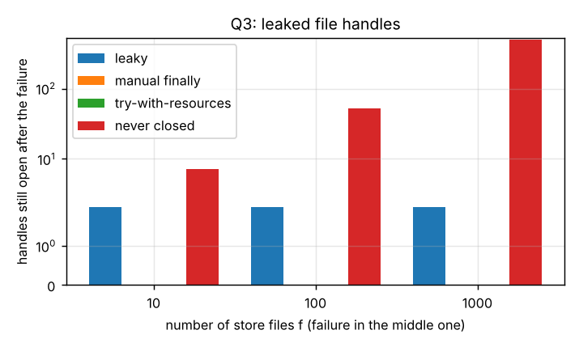
Figure Q3.1 – Handles still open after a failure (symlog axis)
Analysis. Time is Θ(f·m) for every version (all read every line once); the differences (e.g. 27 ms vs 65 ms at f = 1000) are noise and JIT effects, not complexity. The decisive difference is space: with explicit close in finally or with try-with-resources at most 2 handles are open at any time (O(1)) and 0 remain after a failure, whereas the never-closing version holds f + 1 at the end of a success run and f/2 + 2 after a mid-run failure – O(f). That is the "Too many open files" bug, which I reproduced by running the never-closing version under ulimit -n 128 with 400 files:
$ bash -c "ulimit -n 128; java -cp out ReportScaleBenchmark ulimit" 2>&1 | head -3
FAILED after 122 handles were open: /tmp/stores_400_727185945210631951/store00121.csv (Too many open files)

The failure came after 122 open handles (the JVM itself needs a few of the 128 descriptors). The leaky version leaks only 2 per failure, so it fails only after many failed runs in a long-lived process, which is why the bug appears "occasionally". Try-with-resources is retained: same time, O(1) space, no leak, and the suppressed-exception rule keeps the original failure visible.

Q4 – Thread Creation and the Thread Life Cycle (7 marks, K4)

Shared group work – two ways to create the stations
Four scanner stations; each scans a batch of 20 scripts (1–4 ms per script, simulated with Thread.sleep) and the main thread prints the finishing order and the total (expected 4 × 20 = 80). Way 1 StationThread extends Thread, way 2 StationRunnable implements Runnable run by new Thread(task, name); both use start(), sleep(), join() and isAlive().
/** Way 1: EXTEND Thread. */
public class StationThread extends Thread {
private final int batch;
volatile int scanned;
StationThread(String name, int batch) { super(name); this.batch = batch; }
@Override public void run() {
scanned = Scanner1.scan(getName(), batch);
StationsMain.FINISHED.add(getName());
}
}

/** Way 2: IMPLEMENT Runnable (the task is separate from the thread that runs it). */
public class StationRunnable implements Runnable {
private final String name; private final int batch;
volatile int scanned;
StationRunnable(String name, int batch) { this.name = name; this.batch = batch; }
@Override public void run() {
scanned = Scanner1.scan(name, batch);
StationsMain.FINISHED.add(name);
}
}

$ java -cp out StationsMain thread; java -cp out StationsMain runnable
alive right after start(): true true true true
alive after join() : false false false false
finish order: S2 S1 S3 S4 total scripts scanned = 80
finish order: S4 S2 S1 S3 total scripts scanned = 80

Student A – Thread design

A1. Extending Thread vs implementing Runnable
 | extends Thread | implements Runnable
What it is | The task is a thread | The task is separate from the thread that runs it
Inheritance | Uses up the single superclass slot | Class can still extend another class
Reuse | One object = one thread; cannot be handed to an executor as a plain task | The same task can run in a Thread, an ExecutorService, or be run directly; one task object can be shared
Design | Mixes *what* to do with *how* it runs | Separates job from execution mechanism (cleaner, testable)
Preferred when | Rarely – only if the thread behaviour itself (e.g. an overridden interrupt()) is being specialised | Normally: it is the preferred way and the basis for Callable/executors

A2. Life-cycle state diagram – states each station passes through
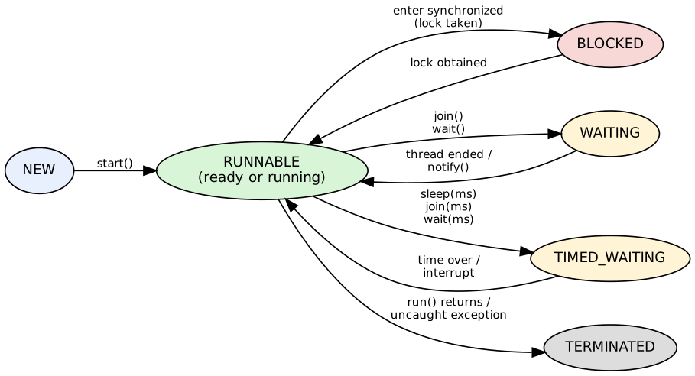
Figure Q4.1 – Thread life cycle (Thread.State). A station passes NEW → RUNNABLE → TIMED_WAITING (every sleep) ↔ RUNNABLE → TERMINATED; main passes through WAITING while in join().
LifeCycleDemo observed one thread in every state with getState():
after new Thread(...) : NEW isAlive=false
50 ms after start(), computing : RUNNABLE isAlive=true
while inside Thread.sleep(300) : TIMED_WAITING
after the run() method ended : TERMINATED isAlive=false
waiting to enter synchronized : BLOCKED
inside wait() : WAITING
inside join() of another thread: WAITING

A3. Why run() does not create a new thread – evidence
run() is an ordinary method: calling t.run() executes the body in the calling thread; only start() asks the JVM to create a new thread, which then calls run().
$ java -cp out RunVsStart
main thread id = 1
calling t.run():
body executed by thread: main (id 1)
t1 state after run(): NEW (the thread was never started)
calling t.start():
body executed by thread: station-2 (id 14)
starting the same thread twice:
java.lang.IllegalThreadStateException
four 100 ms jobs: via run() = 401 ms (sequential, one after another), via start() = 100 ms (overlapping)

Evidence: with run() the body printed main as the thread name and the thread stayed in state NEW; with start() the name was station-2; starting the same thread twice throws IllegalThreadStateException; and four 100 ms jobs took about 400 ms through run() (one after another) versus about 100 ms through start() (overlapping).

A4. How join() ensures the final total is printed after all stations finish
t.join() makes the calling thread (main) wait – state WAITING – until t has terminated. Calling join() on all four stations before printing means main cannot reach the print statement until every station has finished and stored its count.
$ java -cp out JoinDemo
--- without join() ---
total printed immediately by main : 0 (WRONG - stations still scanning)
total after the stations finished : 80
--- with join() ---
total printed after join() : 80 (correct: 4 x 20 = 80)

Without join() main printed a total of 0 immediately (wrong); with join() it printed 80. join() also gives a happens-before guarantee, so main sees the stations' results (scanned) correctly.

Student B – Behavioural experiments

B1. Finishing order over 12 runs (separate JVMs, both ways of creating threads)
Run | Finish order – extends Thread | Finish order – implements Runnable
1 | S3 S1 S4 S2 | S3 S2 S1 S4
2 | S4 S1 S3 S2 | S2 S4 S3 S1
3 | S4 S1 S3 S2 | S4 S1 S2 S3
4 | S4 S2 S1 S3 | S1 S3 S4 S2
5 | S1 S3 S4 S2 | S4 S1 S2 S3
6 | S4 S2 S1 S3 | S4 S2 S1 S3
7 | S4 S3 S2 S1 | S2 S3 S1 S4
8 | S4 S2 S3 S1 | S4 S3 S1 S2
9 | S3 S4 S2 S1 | S4 S3 S2 S1
10 | S4 S2 S3 S1 | S4 S2 S1 S3
11 | S2 S4 S1 S3 | S4 S3 S1 S2
12 | S1 S2 S4 S3 | S2 S4 S1 S3

The total was 80 in all 24 runs (Q4/output/twelve_runs.txt), but the order differs from run to run and there is no stable pattern: S4 finished first in 7 of the 12 Thread runs, S1 and S3 in 2 each and S2 in 1; in the Runnable runs the first finisher was S3, S2, S4, S1, S4, S4, S2, S4, S4, S4, S4, S2. (S1 has no systematic advantage even though it is started first.)

B2. Thread priorities
PriorityExperiment: four CPU-bound stations, 12 repetitions per setting.
all priority 5:
times each station finished FIRST: S1=9 S2=0 S3=2 S4=1
times each station finished LAST : S1=0 S2=3 S3=4 S4=5

S1 = 10 (MAX), S2 = S3 = 5, S4 = 1 (MIN):
times each station finished FIRST: S1=6 S2=3 S3=1 S4=2
times each station finished LAST : S1=1 S2=2 S3=1 S4=8

Did the order change? Not in the way priorities promise. With equal priorities S1 finished first in 9 of 12 runs (it simply started first and got a head start). With S1 at MAX it finished first in only 6 of 12 – *fewer* – and S4 at MIN finished last 8 times against 5 (a small shift that is within the run-to-run noise of 12 samples). On Linux HotSpot (ThreadPriorityPolicy = 0 in this JVM) Java priorities are only hints that the operating system scheduler is free to ignore, and the machine has a single core, so threads are time-sliced regardless of priority. A program must never use priorities for correctness.

B3. Daemon thread when main() ends
$ java -cp out DaemonDemo daemon; echo '--- same program, NOT daemon ---'; java -cp out DaemonDemo
S4 isDaemon = true
S4 scanned script 1
S4 scanned script 2
main() is ending now
--- same program, NOT daemon ---
S4 isDaemon = false
S4 scanned script 1
S4 scanned script 2
main() is ending now
S4 scanned script 3
S4 scanned script 4
S4 scanned script 5
S4 scanned script 6
S4 scanned script 7
S4 scanned script 8
S4 scanned script 9
S4 scanned script 10
S4 scanned script 11
S4 scanned script 12
S4 scanned script 13
S4 scanned script 14
S4 scanned script 15
S4 scanned script 16
S4 scanned script 17
S4 scanned script 18
S4 scanned script 19
S4 scanned script 20
S4 FINISHED its whole batch

S4 is a long task (20 scripts × 50 ms = 1 s); main joins only S1 (≈ 50 ms) and then ends. When S4 is a daemon (first run) the JVM exits as soon as the last non-daemon thread (main) ends: S4 printed only two scripts and never printed "FINISHED" – its work was abandoned. When S4 is a normal (non-daemon) thread (second run) the JVM stays alive until S4 completes all 20 scripts and prints "S4 FINISHED". A daemon is therefore suitable for background housekeeping, never for work that must complete.

B4. Explanation with the behaviour of the thread scheduler
start() only makes a thread *runnable*; which runnable thread gets the CPU, when, and for how long is decided by the operating-system scheduler (time-slicing, interrupts, other processes). The stations sleep for random 1–4 ms periods, so each wake-up depends on timer resolution and on when the scheduler next runs that thread; small timing differences accumulate into different finishing orders. Priorities are hints, the scheduler is not obliged to run a thread just because it was started first, and the order cannot be predicted from the source code.

Joint conclusion – why different output orders, and why a correct program must not depend on the order
The same program produces different orders because the scheduler's decisions depend on things the program does not control (system load, timer granularity, number of cores, JIT warm-up, the JVM and OS version) – the 24 recorded runs above show it. A program whose correctness depends on one order will work on one machine on one day and fail elsewhere or rarely – the hardest kind of defect to reproduce. Correctness must therefore come from explicit coordination (join(), locks, Future.get(), blocking queues), exactly as join() guarantees the total here regardless of the finishing order.

Alternative Concept and Complexity Analysis – ExecutorService with a fixed pool
What the solution would be. The stations become tasks submitted to Executors.newFixedThreadPool(4); a Callable<Integer> returns the count and Future.get() replaces join():
ExecutorService pool = Executors.newFixedThreadPool(4);
List<Future<Integer>> fs = new ArrayList<>();
for (int s = 1; s <= 4; s++) { final int id = s; fs.add(pool.submit(() -> Scanner1.scan("S" + id, 20))); }
int total = 0; for (Future<Integer> f : fs) total += f.get(); // waits, like join(), AND returns the result
pool.shutdown(); pool.awaitTermination(5, TimeUnit.SECONDS);

Completion time. With n tasks of duration t on p threads, tasks run in ⌈n/p⌉ batches, so the time is about ⌈n/p⌉·t – Θ(n/p) while p ≤ the number of tasks that can really run at once. Measured for n = 400 scripts of 5 ms (ExecutorStations, Figure Q4.2):
p (pool threads) | model ⌈n/p⌉ × 5 ms | measured (ms) | efficiency
1 | 2000 | 2069 | 0.97
2 | 1000 | 1032 | 0.97
4 | 500 | 514 | 0.97
8 | 250 | 257 | 0.97
16 | 125 | 132 | 0.94
50 | 40 | 48 | 0.83

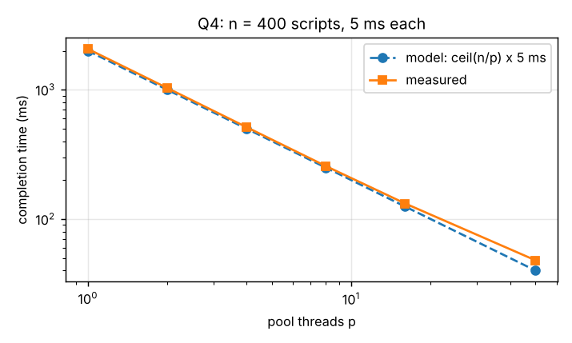
Figure Q4.2 – Pool completion time vs the n/p model
The measurements follow the model to within 3 % up to p = 8 (efficiency 0.97) and degrade at p = 50 (0.83) because 50 threads share one core and the scheduling overhead becomes visible. The four-thread version of the assignment is just n = 4 tasks on p = 4: one batch.
Memory per thread. Every platform thread reserves a stack of 1,024 KB by default (-XX:ThreadStackSize=1024). Measured with 500 parked threads: reserved virtual memory +471040 KB (942 KB per thread, i.e. the 1 MB stack reservation) but only +38180 KB resident (76 KB per thread – stack pages are committed lazily). Hand-made threads: one per task = O(n) threads × stack size (for n = 10,000 scripts: about 10 GB reserved). Fixed pool: O(p) threads, i.e. 4 × 1 MB, independent of the number of tasks. Creation cost: 2,000 tiny tasks took 85.0 ms with a new Thread each (42.5 µs per task) versus 1.2 ms on a pool of 4 (0.6 µs per task) – about 70× cheaper because the pool re-uses its threads. The pool is retained for any realistic number of scripts; hand-made threads are acceptable only for a handful of long-lived tasks.

Q5 – Race Conditions in a Cinema Seat-Booking System (6 marks, K4)

Complete the Code – SeatBooking
The assignment code has no book method at all, so TODO 1 is the whole method. First version, WITHOUT synchronized (SeatBookingUnsync.java, otherwise identical), then the correct one:
// TODO 1 - version 1 (no synchronization) // TODO 1 - version 2 (correct)
void book(int seat) { synchronized void book(int seat) {
if (!booked[seat]) { if (!booked[seat]) { // check ...
booked[seat] = true; booked[seat] = true; // ... then act, as ONE indivisible step
bookingsMade++; bookingsMade++;
} }
} }

Result of 10 runs of the unsynchronized version
Run | Unsynchronized (as given): Seats sold | Unsynchronized + pause between check and book: Seats sold
1 | 10 | 17
2 | 10 | 15
3 | 10 | 17
4 | 10 | 15
5 | 10 | 16
6 | 10 | 12
7 | 10 | 16
8 | 10 | 17
9 | 10 | 15
10 | 10 | 18

Honest observation: the program exactly as given printed Seats sold: 10 in all 10 runs on this machine – the race exists in the code but its window (a few nanoseconds between the if and the assignment) is almost never hit when the 100 threads are started one after another on a single core. That is why such bugs reach production. To see the race the check and the update must be separated by an operation that lets another thread run (a database call or payment step in a real system); with Thread.yield() inserted between them (SeatBookingUnsyncSlow) the program sold 12–18 seats for 10 seats in every run. With the synchronized method (TODO 1 version 2) the program printed the expected output:
$ java -cp out SeatBooking
Seats sold: 10

Why the unsynchronized version may sell more than 10 seats: book is a *check-then-act* sequence. Two threads can both execute the check while the seat is still free, and both then book it; each also increments bookingsMade, so the counter exceeds the number of seats (and because bookingsMade++ is itself a read-modify-write, increments can also be lost). Synchronization makes check and update one atomic unit with respect to other threads using the same lock.

Student A – Producing and explaining the race

A1. A test that reliably reproduces double booking
RaceReproducer: 8 threads wait at a CyclicBarrier and are released together to book the same seat; a trial with more than one "granted" is a double booking. 500 trials per batch, 5 batches per strategy. Thread.yield() between check and set widens the window (the natural window is too small on one core):
Strategy | batch 1 | batch 2 | batch 3 | batch 4 | batch 5 | total | max granted
unsynchronized (natural race) | 0 | 0 | 0 | 0 | 0 | 0 / 2500 | 1
unsynchronized (window widened) | 499 | 499 | 500 | 500 | 500 | 2498 / 2500 | 8
synchronized method | 0 | 0 | 0 | 0 | 0 | 0 / 2500 | 1
synchronized block | 0 | 0 | 0 | 0 | 0 | 0 / 2500 | 1

Double bookings over repeated runs: 2,498 of 2,500 trials with the widened window (up to 8 customers got the same seat); 0 of 2,500 with the natural window on this machine (reported as observed – the natural race did not fire in 2,500 trials); 0 of 2,500 for both synchronized versions.

A2. The race condition step by step (two threads, seat 3)
Step | Thread T1 | Thread T2 | booked[3] | bookingsMade
1 | reads booked[3] → false (seat free) |  | false | 0
2 | *(pre-empted here)* | reads booked[3] → false (still free!) | false | 0
3 |  | sets booked[3] = true | true | 0
4 |  | bookingsMade++ → 1 | true | 1
5 | *(resumes with its old answer "free")* sets booked[3] = true |  | true | 1
6 | bookingsMade++ → 2 |  | true | 2

Both customers were told the seat is theirs, and the counter says 2 sales for 1 seat.

A3. The exact critical section
if (!booked[seat]) { // read booked[seat]
booked[seat] = true; // write booked[seat] } these three statements form the critical section:
bookingsMade++; // read-modify-write } shared mutable state, check-then-act

Everything else in a booking (computing the price, charging the customer, sending the SMS) touches no shared data and does not belong inside the critical section.

Student B – Comparing synchronization strategies

B1. Time to process 10,000 bookings (8 threads, 1,000 seats, each requested 10 times; best of 5)
Strategy | no external work (ms) | with 100 µs payment step per booking (ms) | seats sold (must be 1000)
synchronized method | 0.4 | 1660.5 | 1000 / 1000
synchronized block | 0.4 | 203.8 | 1000 / 1000
ReentrantLock | 0.5 | 205.2 | 1000 / 1000
AtomicBoolean[] CAS | 0.3 | 205.5 | 1000 / 1000
ConcurrentHashMap | 0.6 | 205.0 | 1000 / 1000

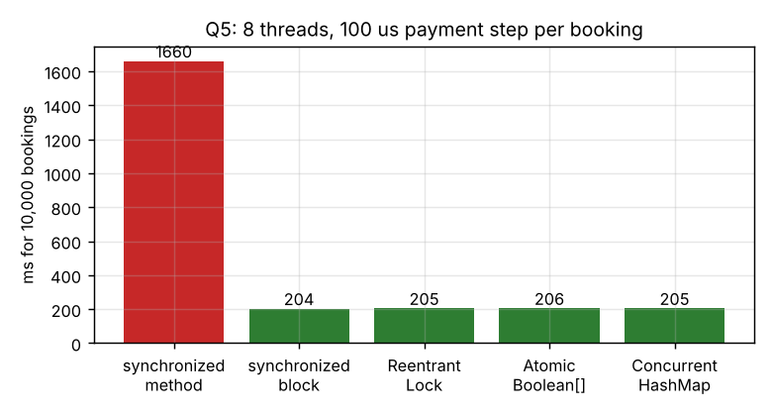
Figure Q5.1 – Locking the whole method vs only the critical section

B2. Locking the whole method vs only the critical section
When the booking does nothing but check-and-set (no external work) all strategies take well under a millisecond for 10,000 bookings (0.3–0.6 ms; the time is dominated by creating threads), so the lock scope does not matter. When each booking also performs a 100 µs step that needs no shared data (payment gateway, SMS), the synchronized method holds the lock during that step, so the 10,000 steps run one after another: 1,660 ms. With a synchronized block around only the check-and-set the steps overlap (the threads wait concurrently): 204 ms – about 8× faster with 8 threads, with the same correctness (1,000 seats sold, none twice). Rule: hold a lock for as short a time as possible, and never while waiting for I/O.

B3. Static synchronization and when it would be needed here
A synchronized instance method locks this; a static synchronized method locks the Class object, one lock for the whole class. It would be needed here for state shared by all screens, e.g. a static counter of tickets sold campus-wide. StaticSyncDemo shows the difference: 4 screens (4 objects, so 4 different this locks) each add 20,000 to one static counter (expected 80,000):
=== 4 screens, each booking 20,000 times into ONE static counter (expected 80000) ===
instance-synchronized (4 different locks): 20000
instance-synchronized (4 different locks): 20002
instance-synchronized (4 different locks): 20000
static synchronized (one Class lock) : 80000
static synchronized (one Class lock) : 80000
static synchronized (one Class lock) : 80000
(Thread.yield() between the read and the write of the counter widens the window so the lost updates are visible on one core)

The instance-synchronized version lost most updates (20,000 instead of 80,000: each screen's lock protects only itself) whereas static synchronized gave exactly 80,000 every time (Thread.yield() between the read and the write widens the window so it is visible on one core). The per-screen booked[] array needs no static lock – it belongs to one screen.

B4. The intrinsic lock each version uses
=== Which intrinsic lock does each form use? ===
synchronized method holds this lock : true holds class lock: false
synchronized (this) holds this lock : true
synchronized (private) holds the private lock : true holds this lock: false
static synchronized holds the Class lock : true

Version | Intrinsic lock (monitor)
synchronized void book() | this – the SeatBooking object of that screen
synchronized (lock) { ... } block | the private lock object (any object); this could be used too
static synchronized | the Class object (SeatBooking.class) – shared by all instances
ReentrantLock (alternative) | an explicit lock object, not the intrinsic monitor

Joint engineering decision – which strategy for a cinema with 20 screens?
One lock per screen: each screen is its own SeatBooking object, so a synchronized instance method or block locks only that screen; bookings on different screens never wait for each other (a single global or static lock would serialise all 20 screens for no reason). Inside a screen, lock only the check-and-set (synchronized block) and do the payment and notification outside the lock – measured 8× faster than locking the whole method when each booking has a 100 µs external step. AtomicBoolean.compareAndSet is a good alternative if the same seat is requested extremely often (measured 8–12 ns per booking against 14–23 ns), but it needs one object per seat (20 bytes against 1 byte per seat). Rules for deployment: never hold the lock while calling out of the process, keep the critical section to three statements, and use AtomicInteger/LongAdder for any campus-wide static counter.

Alternative Concept and Complexity Analysis – AtomicBoolean[], ReentrantLock, ConcurrentHashMap
// AtomicBoolean[] with compareAndSet // ReentrantLock // ConcurrentHashMap.putIfAbsent
boolean book(int seat) { lock.lock(); boolean book(int seat) {
if (booked[seat].compareAndSet(false, true)) { try { if (!booked[seat]) {...} } return map.putIfAbsent(seat, TRUE) == null;
sold.incrementAndGet(); return true; } finally { lock.unlock(); } }
return false; }

Time per booking under contention (400,000 attempts, 8 threads; HOT = 10 seats so many threads compete for the same seats, SPREAD = 100,000 seats so they rarely meet), ns per booking, best of 5, and extra space for s seats:
Strategy | HOT (ns) | SPREAD (ns) | Extra space for s seats
synchronized method | 15 | 14 | s bytes (boolean[]) + O(1) lock
synchronized block | 14 | 17 | s bytes + O(1) lock
ReentrantLock | 23 | 23 | s bytes + one lock object (~48 bytes)
AtomicBoolean[] CAS | 8 | 12 | ≈ 20 bytes per seat (AtomicBoolean object + reference) = 20·s
ConcurrentHashMap | 10 | 66 | ≈ 58 bytes per sold seat (node + Integer key + table slot) = O(s)

Analysis. Every strategy performs a booking in O(1) time. Under contention the compare-and-set version is fastest on a hot seat (8 ns) because a loser fails immediately without blocking; the lock-based versions pay for lock hand-over (14–23 ns). ConcurrentHashMap is cheap for few keys (10 ns) but slows to 66 ns when the map holds 100,000 entries (hashing, node allocation, cache misses). Space: boolean[] guarded by one lock is the smallest (s bytes); AtomicBoolean[] costs ≈ 20 s bytes; ConcurrentHashMap ≈ 58 s bytes. On this single-core machine true parallel contention cannot occur, so absolute numbers should be re-measured on a multi-core computer; the ordering of space costs and the lock-scope result are architecture-independent.

Q6 – Deadlock and Inter-Thread Communication (7 marks, K4)

Complete the Code – TokenCounter (Part B)
Note: the printed code is missing the closing brace of the lambda of the student threads (it appears detached at the end of the table in the assignment); one } was added so that the program compiles. Nothing else outside the TODOs changed.
public class TokenCounter {
private final int[] buffer = new int[5]; // the counter holds at most 5 tokens
private int count = 0, in = 0, out = 0;

public synchronized void put(int token) throws InterruptedException {
// TODO 1: Wait while the counter is full, add the token at position in, then
// wake waiting threads
while (count == buffer.length) wait(); // loop: the condition is re-tested after every wake-up
buffer[in] = token;
in = (in + 1) % buffer.length;
count++;
notifyAll();
}

public synchronized int take() throws InterruptedException {
// TODO 2: Wait while the counter is empty, remove the token at position out,
// wake waiting threads and return the token
while (count == 0) wait();
int token = buffer[out];
out = (out + 1) % buffer.length;
count--;
notifyAll();
// ... (26 more lines in the repository)

Expected output | Actual output
Sum of tokens collected: 210 (expected 210) | Sum of tokens collected: 210 (expected 210)

Change while to if in both methods and run several times
Run | Sum of tokens (expected 210)
1 | 175
2 | 210
3 | 210
4 | 185
5 | 175
6 | 175
7 | 200
8 | 200
9 | 200
10 | 60

With if, 8 of the 10 runs produced a wrong sum (175, 185, 200, 60 …) while while always gave 210. Explanation: a thread that waited in if (count == 0) wait(); continues *without testing again* after it is woken. With notifyAll() both consumers wake up; the first takes the only token, the second then also proceeds although count is 0 again – it removes a token that is not there (it re-reads a stale slot and drives count to −1). Wrong sums, repeated and missing tokens, and a counter outside 0..5 follow. Spurious wake-ups (allowed by the Java specification) cause the same error even with a single consumer.

Student A – Producer–consumer design

A1. Why wait() must be in a loop and in a synchronized block
- Synchronized: wait() releases the monitor and later re-acquires it, and the condition (count == 0) is shared state that must be tested while holding that same lock, otherwise a wake-up could be lost between the test and the wait. A call without owning the monitor throws IllegalMonitorStateException.
- Loop: after being woken the thread must re-test the condition, because (1) another thread may have changed it first (the two-consumer case above), (2) notifyAll() wakes *every* waiter although only one can proceed, and (3) the JVM may wake a thread spuriously. while is therefore the only correct form; evidence: 8 wrong runs of 10 with if, none with while.

A2. notify() instead of notifyAll() with several consumers
CounterStress (10 trials each, 2-second watchdog; HUNG = threads still blocked):
Configuration | Outcomes of 10 trials
while, capacity 5, 1 producer, 2 consumers (the assignment) | OK=10
if, capacity 5, 1 producer, 2 consumers (the assignment) | OK=7, SIZE OUT OF RANGE=3
while, capacity 1, 2 producers, 4 consumers, 500 tokens each | OK=10
if, capacity 1, 2 producers, 4 consumers, 500 tokens each | SIZE OUT OF RANGE=10
notifyAll, 1 producer, 2 consumers, capacity 5 | OK=10
notify, 1 producer, 2 consumers, capacity 5 | OK=10
notifyAll, 2 producers, 4 consumers, capacity 1 | OK=10
notify, 2 producers, 4 consumers, capacity 1 | HUNG=10

In the assignment's design (1 producer, 2 consumers, capacity 5) notify() worked in all 10 trials: the waiting set contains threads of one kind at a time (the producer waits only when the buffer is full, consumers only when it is empty – never both), so waking any one waiter always helps. With several producers and several consumers (2 producers, 4 consumers, capacity 1) notify() hung in all 10 trials: a consumer's notify() can wake another *consumer*, which finds the buffer empty and waits again, while the producer that should have been woken stays asleep – the wake-up is consumed by the wrong thread and every thread ends up waiting. notifyAll() is correct in both cases because all waiters re-test their condition.

A3. Counter size over time – never above 5 or below 0
$ java -cp out CounterTrace
counter size after each of the 40 operations (put or take):
[1, 2, 3, 4, 5, 4, 3, 4, 5, 4, 5, 4, 5, 4, 5, 4, 5, 4, 3, 4, 5, 4, 5, 4, 5, 4, 3, 4, 5, 4, 5, 4, 5, 4, 5, 4, 3, 2, 1, 0]
minimum size seen = 0, maximum size seen = 5 (limits: 0 and 5)
sum of tokens = 210 (expected 210), final size = 0

The size was recorded after each of the 40 operations: it stays between 0 and 5 (minimum 0, maximum 5) and the sum is 210. In the stress test with if, the same monitor reported sizes outside the range (see the table), which is how the defect was detected.

A4. sleep() versus wait()
holder thread is inside synchronized(LOCK) for 400 ms; another thread tries to enter 100 ms later:
holder uses Thread.sleep(400): the other thread got in after 300 ms (sleep KEEPS the lock)
holder uses LOCK.wait(400) : the other thread got in after 0 ms (wait RELEASES the lock)

 | Thread.sleep(ms) | Object.wait()
Defined in | Thread (static) | Object (instance, on the monitor)
Lock | keeps every lock it holds (the other thread entered after 300 ms) | releases the monitor (the other thread entered after 0 ms)
Must be in synchronized? | No | Yes
Wakes up | when the time is over (or interrupt) | on notify()/notifyAll(), timeout (if given), or interrupt
Purpose | pause | wait for a condition to change

Student B – Deadlock analysis and prevention (Part A)

B1. A pair of transfers that reliably deadlocks
transferUnsafe(from, to) locks from, pauses 200 ms (so the bad interleaving is certain), then locks to. T1 = A → B and T2 = B → A:
Thread t1 = new Thread(() -> Wallet.transferUnsafe(a, b, 100, 200), "Transfer-1 (A -> B)");
Thread t2 = new Thread(() -> Wallet.transferUnsafe(b, a, 50, 200), "Transfer-2 (B -> A)");

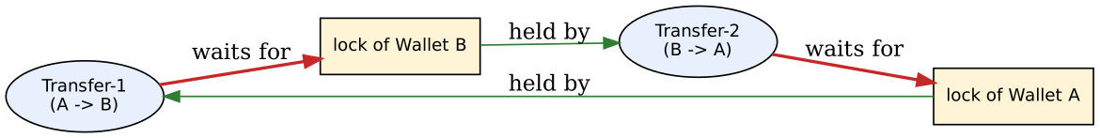
Figure Q6.1 – Wait-for graph: each transfer holds one wallet and waits for the other (a cycle)
$ java -cp out DeadlockDemo
DEADLOCK DETECTED among 2 threads:
thread : Transfer-1 (A -> B) state = BLOCKED
waiting for lock : Wallet@4dd8dc3
which is held by : Transfer-2 (B -> A)
thread : Transfer-2 (B -> A) state = BLOCKED
waiting for lock : Wallet@6f496d9f
which is held by : Transfer-1 (A -> B)
balances unchanged: A=1000 B=1000 (neither transfer completed; both threads wait forever)
t1 alive=true t2 alive=true -> exiting the JVM with System.exit(0)

ThreadMXBean.findDeadlockedThreads() reported both threads in state BLOCKED, each waiting for the lock the other owns; neither transfer completed (balances unchanged) and the program had to be ended with System.exit.

B2. The four conditions for deadlock present in the program
Condition | Present in the program?
Mutual exclusion – a resource is held by one thread at a time | Yes – a wallet's monitor can be owned by only one thread
Hold and wait – a thread holds a resource while waiting for another | Yes – each transfer holds the first wallet while waiting for the second
No pre-emption – a held resource cannot be taken away | Yes – a monitor cannot be taken from its owner
Circular wait – a cycle of threads each waiting for the next | Yes – T1 → B (held by T2) and T2 → A (held by T1)

B3. Prevention with a consistent lock-ordering rule, and why it works
static void transferOrdered(Wallet from, Wallet to, long amount) {
Wallet first = from.id < to.id ? from : to; // ALWAYS lock the wallet with the smaller id first
Wallet second = from.id < to.id ? to : from;
synchronized (first) { synchronized (second) { from.balance -= amount; to.balance += amount; } }
}

Why it works: the rule breaks the fourth condition, circular wait. All threads acquire locks in one global order (increasing id), so a thread holding wallet *i* can only ever wait for a wallet with a larger id; a cycle would need some thread to wait for a smaller id, which the rule forbids. Hence the wait-for graph cannot contain a cycle. Both original transfers now both lock wallet 1 first: one of them waits briefly and then proceeds.
$ java -cp out DeadlockFixed
=== The two conflicting transfers with lock ordering (lower wallet id locked first) ===
both transfers completed: A=950 B=1050 (expected A=950, B=1050)

=== Stress: 8 threads x 200 random transfers between 6 wallets, 1 ms pause between the two locks ===
unsafe order (from, to) HUNG (deadlock) money before=60000 after=60000 (conserved) time=5011 ms
ordered locks (lower id first) finished money before=60000 after=60000 (conserved) time=641 ms
tryLock with timeout + back-off finished money before=60000 after=60000 (conserved) time=1508 ms

Both transfers completed (A = 950, B = 1050). In the stress test (8 threads, random transfers between 6 wallets, 1 ms pause between the two locks) the unsafe order hung (deadlock found after the 5-second watchdog), while ordered locking finished and the total money was conserved (60,000 before and after).

Joint conclusion – what deadlock and producer–consumer have in common, and how each ensures progress
Both are coordination problems between threads that wait for each other: threads block until a condition that *another thread* must establish (a lock released, a slot freed, a token produced). Both can leave all threads waiting forever if the design is wrong (circular wait; a lost or wrongly targeted wake-up – the notify() hang above). Progress is ensured differently: the wallet design guarantees progress by removing the cycle (a global lock order, so some thread can always acquire its second lock); the token counter guarantees progress by the condition protocol – every state change (put, take) calls notifyAll(), every waiter re-tests its condition in a while loop, and a full counter can always be emptied by consumers while an empty one can be refilled by the cook.

Alternative Concept and Complexity Analysis – ArrayBlockingQueue and tryLock with a timeout
Part B with ArrayBlockingQueue<Integer>(5) (TokenQueueDemo) – no wait/notify code at all; the queue blocks put when full and take when empty and does the locking internally:
BlockingQueue<Integer> counter = new ArrayBlockingQueue<>(5);
cook: for (int t = 1; t <= 20; t++) counter.put(t); students: collected[id] += counter.take(); // output: Sum ... 210

Part A with tryLock(timeout) (Wallet.transferTryLock): lock from with tryLock(5 ms); if the second lock is not obtained within 5 ms, release the first, wait a random 1–10 ms and retry. Deadlock cannot persist because the *hold-and-wait* condition is broken (a thread gives up what it holds).
while (true) {
if (from.lock.tryLock(5, MILLISECONDS)) {
try { if (to.lock.tryLock(5, MILLISECONDS)) { try { move money; return; } finally { to.lock.unlock(); } } }
finally { from.lock.unlock(); } // could not get the second lock: give up the first
}
Thread.sleep(random 1..10 ms); // random back-off avoids live-lock
}

N tokens (1 producer, 2 consumers, capacity 5) | wait()/notifyAll() (best of 3) | ArrayBlockingQueue(5) (best of 3)
10000 | 16 ms (1.56 µs/token) | 24 ms (2.41 µs/token)
50000 | 54 ms (1.08 µs/token) | 58 ms (1.17 µs/token)
100000 | 103 ms (1.03 µs/token) | 105 ms (1.05 µs/token)

Transfers (8 threads × 1,000 random, 6 wallets, no pause) | Time | Per transfer
ordered synchronized locks | 32 ms | 4.76 µs
tryLock(5 ms) + back-off | 317 ms | 47.48 µs

Space | wait/notify counter | ArrayBlockingQueue(5)
bytes per object (measured) | 130 (int[5] + fields + monitoring list; the counter itself is 5 ints + 3 ints) | 188 (Object[5] + ReentrantLock + 2 Conditions; boxed Integers above 127 add 16 bytes each)

Analysis. put/take are O(1) in both implementations; measured 1.0–1.6 µs per token for wait/notifyAll and 1.0–2.4 µs for the queue – equal for practical purposes (the cost is the thread hand-over, not the data structure). Space is O(capacity) for both (a few hundred bytes). Transfers: ordered locking costs one acquisition per wallet, Θ(1) (≈ 4–5 µs here); tryLock is about 10× slower under contention (≈ 47 µs per transfer) because failed attempts wait up to 5 ms and then back off, and on one core a thread holding a lock is often descheduled, so the others time out and retry. Which design is less error-prone? ArrayBlockingQueue – the while/notifyAll protocol, whose three classic mistakes (if, notify, missing synchronized) all failed in the experiments above, simply does not exist. For transfers, lock ordering is simpler and faster, but it needs a global ordering key that every caller respects (easy to violate when a third lock appears); tryLock tolerates a violated order but adds timeouts, retries and possible live-lock, so it is the better choice only when no ordering can be defined.

Q7 – Design a Concurrent, Fault-Tolerant Processor from First Principles (10 marks, K5)

Stage 1 – Interpret the problem (joint, 2 marks)

1.1 Tasks that can run in parallel, and the data that is shared
 | Content
Independent tasks (can run in parallel) | "Read, validate and score ONE file" – the 10,000 tasks do not depend on each other: each reads its own file, parses its own text and computes its own result. This is an I/O-bound job (waiting for the storage), so overlapping tasks shortens the total time.
Data that is NOT shared | File content, the parsing state and the score of one student – private to one task (on its stack).
Data that IS shared | (1) the result collection that every task writes to and the summary reads; (2) the list of files (read-only after creation, so safe); (3) the worker threads' queue (managed by the executor).
Must be sequential | Building the summary – it needs all results, so it must happen only after every task has finished.

1.2 Every failure that can occur and how each must be handled
Failure | Exception raised | Handling | Recorded as
File listed but missing | NoSuchFileException | Caught in the task | MISSING
Empty file; wrong number of fields; bad student id; mark not a number; mark outside 0–100 | CorruptFileException (user-defined, checked) | Caught in the task | CORRUPT + reason
Bytes that are not valid text (binary garbage) | CharacterCodingException | Caught in the task (found by testing, see Stage 3) | CORRUPT
Path is a directory / unreadable / I/O error | IOException | Caught in the task | ERROR + message
Programming bug inside a task | RuntimeException | Caught in the task; a second safety net in the processor (ExecutionException from Future.get()) | ERROR
An Error thrown inside a task | e.g. AssertionError (injected) | Not caught by the task; the Future captures it and the processor records it | ERROR
Interrupt during the run | InterruptedException | Flag restored, task ends | ERROR ("interrupted")
Pool cannot be stopped in time | – | shutdown() + awaitTermination + shutdownNow() in finally | –

1.3 Requirements stated as measurable statements
# | Requirement | How it is measured
R1 | A failure in one file must never stop or fail the run | Fault injection: with bad files and exceptions thrown inside tasks the run still finishes and reports all files
R2 | Completeness: every submitted file appears in the summary exactly once | success + corrupt + missing + error == submitted (the complete flag) in every run
R3 | Correctness: summary counts equal the true counts | Hand-checked set of 15 files; generated set of 10,000 files compared with the ground truth written by the generator
R4 | Each failed file is listed with its name and reason | Failure list of the summary compared with the injected faults
R5 | Speed: 10,000 files must finish in a time that falls as threads increase while the work is I/O-bound | Total time with pools of 1, 2, 4, 8 (and 16, 32) threads, 7 runs each
R6 | Resources: at most p worker threads; no file handle left open | Peak thread count; every file read through Files.readString (closed by the call)
R7 | The result must not depend on thread count or scheduling | Same counts for every pool size and every run (correct = true in all 54 timed runs)

Stage 2 – Design (Student A, 3 marks)

2.1 Design with ExecutorService, Callable and Future
- ResultProcessor.process(files, p, latency) creates Executors.newFixedThreadPool(p) – p worker threads re-used for all 10,000 tasks.
- One Callable<FileResult> (ScoreFileTask) is submitted per file; submit returns a Future<FileResult> that is kept in a list.
- A task never throws for an expected problem: it converts every failure into a FileResult with a Status, writes it into the shared map and returns it.
- The processor then calls future.get() on every future – this waits for the task and is the safety net: if the task itself threw (bug or Error), get() throws ExecutionException and the processor records an ERROR result for that file.
- Only after all futures are done and the pool is shut down (in finally) is the Summary built from the map – so the summary can never see a half-finished run.

2.2 Choice of the concurrent collection for the shared results, and justification
ConcurrentHashMap<String, FileResult> keyed by file name.
Candidate | Verdict
HashMap / ArrayList (not thread-safe) | Rejected – concurrent put/add can lose entries or corrupt the structure (the same race as Q5).
Collections.synchronizedList/Map | Correct, but one lock for all 10,000 writers: threads queue up on it.
CopyOnWriteArrayList | Rejected – every add copies the whole array: O(n) per write, O(n²) for 10,000 results; designed for read-mostly data.
ConcurrentLinkedQueue | Fast and non-blocking, but cannot answer "is this file already recorded?" and has no key – the summary could not detect a missing or duplicate entry.
ConcurrentHashMap (chosen) | Many writers at once with fine-grained locking/CAS (low contention); put and putIfAbsent are atomic, O(1) expected; the key = file name makes it impossible to record a file twice and lets putIfAbsent act as the "record only if the task did not" operation used in the ExecutionException fallback; size() after the run is the completeness check.

2.3 Exception handling so that one failure does not stop the run
- Layer 1 – inside the task: catch blocks ordered from narrow to broad (NoSuchFileException → MISSING, CorruptFileException → CORRUPT, CharacterCodingException → CORRUPT, IOException → ERROR, InterruptedException → ERROR with the interrupt flag restored, RuntimeException → ERROR). The sink.put(...) is executed on every path, so exactly one result exists per file.
- Layer 2 – in the processor: Future.get() is wrapped in try/catch (ExecutionException | CancellationException); the file gets an ERROR result via putIfAbsent. This also covers an Error (e.g. AssertionError) that the task did not catch.
- Layer 3 – resources: pool.shutdown() in finally, awaitTermination, then shutdownNow(); files are read with Files.readString, which opens and closes the file itself (nothing to leak).
- Why the run cannot be stopped: no exception is allowed to leave the loop over the futures, and no task depends on another.

2.4 Class diagram
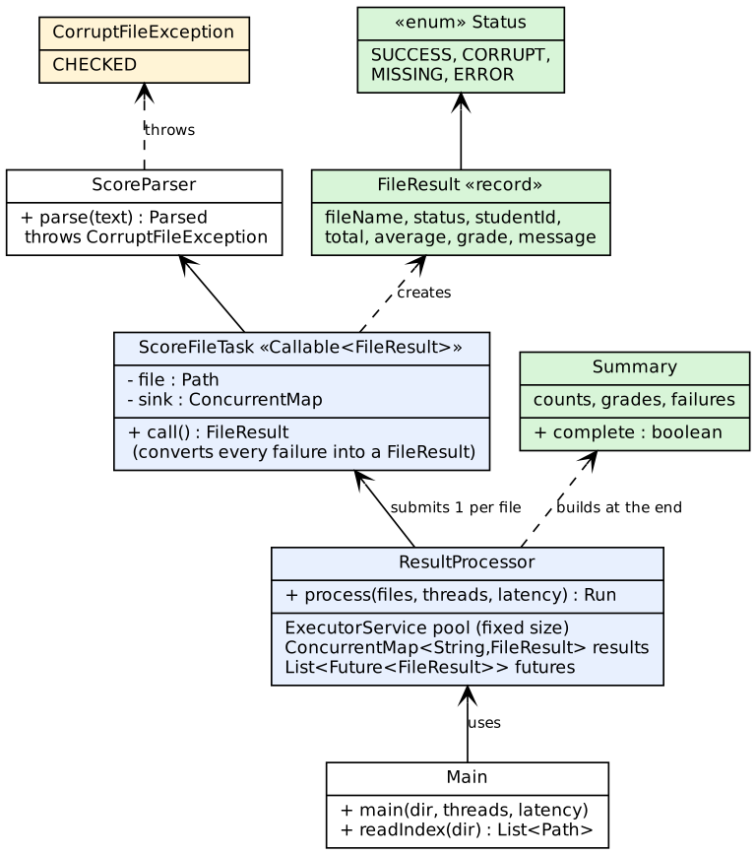
Figure Q7.1 – Class diagram of the result processor

2.5 Pseudocode
ALGORITHM ProcessAll
INPUT : files[1..N], p (pool size), latency (simulated, may be 0)
OUTPUT : Summary
BEGIN
results ← NEW ConcurrentHashMap() // shared, thread-safe
pool ← NEW FixedThreadPool(p)
futures ← EMPTY LIST
TRY
FOR EACH file IN files DO
futures.ADD( pool.SUBMIT( NEW ScoreFileTask(file, results, latency) ) )
END FOR
FOR EACH (file, future) IN futures DO // wait for every task
TRY future.GET()
CATCH ExecutionException, CancellationException
results.PUT_IF_ABSENT(name(file), FileResult(name(file), ERROR, ...)) // safety net
END TRY
END FOR
FINALLY
pool.SHUTDOWN(); IF NOT pool.AWAIT_TERMINATION(30 s) THEN pool.SHUTDOWN_NOW()
END TRY
RETURN Summary(N, results.VALUES()) // built only after everything has finished
END

ALGORITHM ScoreFileTask.Call(file) // runs on a worker thread
BEGIN
TRY
IF latency > 0 THEN SLEEP(latency) // simulated slow storage
text ← READ_WHOLE_FILE(file)
parsed ← ParseScore(text) // may raise CorruptFileException
result ← FileResult(SUCCESS, id, total, average, grade)
CATCH NoSuchFile : result ← FileResult(MISSING)
CATCH CorruptFile : result ← FileResult(CORRUPT, reason)
CATCH CharacterCoding : result ← FileResult(CORRUPT, "not valid text")
CATCH IOException : result ← FileResult(ERROR, message)
CATCH Interrupted : RESTORE interrupt flag; result ← FileResult(ERROR, "interrupted")
CATCH RuntimeException : result ← FileResult(ERROR, class + message)
END TRY
results.PUT(name(file), result) // EVERY path records exactly one result
RETURN result
END

ALGORITHM ParseScore(text)
IF text IS BLANK THEN RAISE CorruptFile("empty file")
fields ← SPLIT(text, ","); IF COUNT(fields) ≠ 6 THEN RAISE CorruptFile(...)
IF fields[1] DOES NOT MATCH "S" + 5 digits THEN RAISE CorruptFile(...)
FOR i ← 2 TO 6 DO m ← INTEGER(fields[i]) OR RAISE CorruptFile; IF m < 0 OR m > 100 THEN RAISE CorruptFile
total ← SUM(marks); average ← total / 5
grade ← FAIL IF any mark < 35; ELSE A (≥75), B (≥60), C (≥50), D (≥40), otherwise FAIL

package results;

import java.io.IOException;
import java.nio.file.*;
import java.util.concurrent.Callable;
import java.util.concurrent.ConcurrentMap;

/** One unit of work: read, validate and score ONE file. It converts every expected failure into a FileResult. */
public class ScoreFileTask implements Callable<FileResult> {
private final Path file; private final ConcurrentMap<String, FileResult> sink; private final long latencyMicros;

public ScoreFileTask(Path file, ConcurrentMap<String, FileResult> sink, long latencyMicros) {
this.file = file; this.sink = sink; this.latencyMicros = latencyMicros;
}

@Override public FileResult call() {
String name = file.getFileName().toString();
FileResult r;
try {
if (latencyMicros > 0) Thread.sleep(latencyMicros / 1000, (int) (latencyMicros % 1000) * 1000); // SIMULATED storage latency
String content = Files.readString(file); // NoSuchFileException if missing
ScoreParser.Parsed p = ScoreParser.parse(content);
r = FileResult.ok(name, p.id(), p.total(), p.average(), p.grade());
} catch (NoSuchFileException e) {
r = FileResult.failed(name, Status.MISSING, "file not found");
} catch (CorruptFileException e) {
r = FileResult.failed(name, Status.CORRUPT, e.getMessage());
} catch (java.nio.charset.CharacterCodingException e) { // FIX after the hand-checked test: bytes that are not valid text
r = FileResult.failed(name, Status.CORRUPT, "not valid UTF-8 text");
} catch (IOException e) {
r = FileResult.failed(name, Status.ERROR, "I/O error: " + e.getMessage());
} catch (InterruptedException e) {
Thread.currentThread().interrupt(); // keep the interrupt flag for the pool
r = FileResult.failed(name, Status.ERROR, "interrupted");
} catch (RuntimeException e) { // a bug must not stop the run either
r = FileResult.failed(name, Status.ERROR, "unexpected " + e.getClass().getSimpleName() + ": " + e.getMessage());
}
sink.put(name, r); // shared result map: many threads write concurrently
return r;
}
}

package results;

import java.nio.file.Path;
import java.util.*;
import java.util.concurrent.*;

/** Design: ExecutorService + Callable + Future + ConcurrentHashMap. One bad file can never stop the run. */
public class ResultProcessor {
public record Run(Summary summary, double millis) { }

/** Creates the Callable for one file (a test can supply a faulty one). */
public interface TaskFactory { Callable<FileResult> create(Path file, ConcurrentMap<String, FileResult> sink, long latencyMicros); }

public static Run process(List<Path> files, int threads, long latencyMicros) throws InterruptedException {
return process(files, threads, latencyMicros, ScoreFileTask::new);
}

public static Run process(List<Path> files, int threads, long latencyMicros, TaskFactory factory) throws InterruptedException {
ConcurrentMap<String, FileResult> results = new ConcurrentHashMap<>(Math.max(16, files.size() * 2));
ExecutorService pool = Executors.newFixedThreadPool(threads);
long t0 = System.nanoTime();
List<Map.Entry<Path, Future<FileResult>>> futures = new ArrayList<>(files.size());
try {
for (Path f : files) futures.add(Map.entry(f, pool.submit(factory.create(f, results, latencyMicros))));
for (Map.Entry<Path, Future<FileResult>> e : futures) {
String name = e.getKey().getFileName().toString();
try {
e.getValue().get(); // wait for this file's task
} catch (ExecutionException ex) { // the task itself threw: still record the file
results.putIfAbsent(name, FileResult.failed(name, Status.ERROR, "task failed: " + ex.getCause()));
} catch (CancellationException ex) {
results.putIfAbsent(name, FileResult.failed(name, Status.ERROR, "cancelled"));
}
}
} finally {
pool.shutdown(); // always release the worker threads
if (!pool.awaitTermination(30, TimeUnit.SECONDS)) pool.shutdownNow();
}
double ms = (System.nanoTime() - t0) / 1e6;
return new Run(new Summary(files.size(), results.values()), ms);
}
}

Stage 3 – Implement and measure (Student B, 3 marks)

3.1 Implementation, with corrupt and missing files injected
GenerateScores creates N files with a fixed seed: 2 % are missing (listed in index.txt but never created), 3 % corrupt in three ways (non-numeric mark, mark 150, empty file), the rest valid. It also writes expected_summary.txt – the ground truth. The 15-file hand-checked set Q7/input/handset adds the unusual faults (directory instead of file, binary bytes, wrong field count).

3.2 Summary counts verified for a small hand-checked set (15 files)
File | Content | Hand-calculated result
f01 | S00001,80,70,90,60,75 | SUCCESS: total 375, average 75.0, grade A
f02 | S00002,60,65,70,55,62 | SUCCESS: 312, 62.4, B
f03 | S00003,50,52,55,51,53 | SUCCESS: 261, 52.2, C
f04 | S00004,45,42,40,44,41 | SUCCESS: 212, 42.4, D
f05 | S00005,90,90,90,90,30 | SUCCESS: 390, 78.0, FAIL (one mark below 35)
f06 | S00006,100,100,100,100,100 | SUCCESS: 500, 100.0, A
f07 | S00007,0,0,0,0,0 | SUCCESS: 0, 0.0, FAIL
f08 | S00008,70,eighty,60,50,40 | CORRUPT (mark not a number)
f09 | S00009,70,60,50,40,101 | CORRUPT (mark out of range)
f10 | (empty file) | CORRUPT (empty)
f11 | S00011,70,60,50 | CORRUPT (4 fields instead of 6)
f12, f13 | (files do not exist) | MISSING ×2
f14 | bytes FF FE 00 80 C3 28 | CORRUPT (not valid text)
f15 | a directory named f15.txt | ERROR (cannot be read as a file)

Hand totals: 7 successes, 5 corrupt, 2 missing, 1 error; grades A = 2 (f01, f06), B = 1, C = 1, D = 1, FAIL = 2 (f05, f07); mean of the seven averages = (75 + 62.4 + 52.2 + 42.4 + 78 + 100 + 0) / 7 = 58.57.
$ java -cp out results.Main input/handset 4
SUMMARY submitted=15 success=7 corrupt=5 missing=2 error=1 complete=true
grades {A=2, B=1, C=1, D=1, FAIL=2} mean average of successful files = 58.57
failures (8):
f08.txt [CORRUPT] mark 2 is not a number: 'eighty'
f09.txt [CORRUPT] mark 5 out of range 0..100: 101
f10.txt [CORRUPT] empty file
f11.txt [CORRUPT] expected 6 fields, found 4
f12.txt [MISSING] file not found
f13.txt [MISSING] file not found
f14.txt [CORRUPT] not valid UTF-8 text
f15.txt [ERROR] I/O error: Is a directory
time = 37 ms with 4 thread(s), simulated latency 0 us
expected submitted=15 success=7 corrupt=5 missing=2 error=1
actual submitted=15 success=7 corrupt=5 missing=2 error=1
MATCH

The program output equals the hand calculation exactly (MATCH). For the large set, the same check against the generator's ground truth:
$ java -cp out results.GenerateScores 10000 data; java -cp out results.Main data 4
generated 10000 entries in data: submitted=10000 success=9548 corrupt=260 missing=192 error=0
SUMMARY submitted=10000 success=9548 corrupt=260 missing=192 error=0 complete=true
grades {A=1291, B=3952, C=1201, D=119, FAIL=2985} mean average of successful files = 64.79
failures (452):
... 442 more
time = 460 ms with 4 thread(s), simulated latency 0 us
expected submitted=10000 success=9548 corrupt=260 missing=192 error=0
actual submitted=10000 success=9548 corrupt=260 missing=192 error=0
MATCH

3.3 A failure that was not handled correctly (recorded as it happened)
In my first version of ScoreFileTask there was no handler for CharacterCodingException. The hand-checked set exposed it at once: the binary file f14.txt was reported as ERROR ("I/O error: Input length = 1") instead of CORRUPT, so the summary read corrupt=4 error=2 instead of corrupt=5 error=1 (MISMATCH). The cause: Files.readString decodes UTF-8 and throws MalformedInputException (a subclass of IOException) for invalid bytes; it fell into the generic IOException handler. Fix: a catch (CharacterCodingException e) placed before catch (IOException e) → CORRUPT. The failing run is preserved in Q7/output/first_run_defect.txt:
$ java -cp out results.Main input/handset 4 # FIRST version of ScoreFileTask (no CharacterCodingException handler)
f11.txt [CORRUPT] expected 6 fields, found 4
f14.txt [ERROR] I/O error: Input length = 1
expected submitted=15 success=7 corrupt=5 missing=2 error=1
actual submitted=15 success=7 corrupt=4 missing=2 error=2
MISMATCH

Fault injection inside the tasks (FaultInjectionTest): the task for f03 (a good file) throws an IllegalStateException and the task for f08 throws an AssertionError (an Error). The run still completed, and both files were recorded as ERROR by the Future safety net:

expected: 15 submitted; f03 (was SUCCESS) and f08 (was CORRUPT) now ERROR -> success=6 corrupt=4 missing=2 error=3 (1 directory + 2 injected)
actual : submitted=15 success=6 corrupt=4 missing=2 error=3
PASS - the run was not stopped, every file is accounted for, and the two injected failures are reported

(My first expected value in this test contained an arithmetic slip – error should be 1 + 2 = 3, not 4. The program's answer was right and the expectation in the test was corrected.)

3.4 Total time with pools of 1, 2, 4 and 8 threads (10,000 files)
Two settings were measured, because they answer different questions. A: real file reading only. B: the same plus a simulated 500 µs storage latency per file (a network drive or busy disk) – this is a *simulation*, stated as such. 25 warm-up runs preceded the timed runs; each configuration was timed 7 times (A) or 2 times (B); raw data: Q7/output/measurements.csv. The machine has one CPU core.
Threads | A: all runs (ms) | best | median | speed-up | summary correct
1 | 88, 153, 131, 96, 90, 95, 88 | 88 | 95 | 1.00× | true
2 | 45, 50, 43, 44, 38, 38, 36 | 36 | 43 | 2.21× | true
4 | 35, 41, 37, 36, 36, 42, 48 | 35 | 37 | 2.57× | true
8 | 40, 38, 37, 41, 47, 43, 40 | 37 | 40 | 2.37× | true
16 | 44, 42, 39, 42, 43, 44, 41 | 39 | 42 | 2.26× | true
32 | 46, 58, 55, 53, 46, 46, 49 | 46 | 49 | 1.94× | true

Threads | B: all runs (ms) | best | median | speed-up | summary correct
1 | 6368, 6354 | 6354 | 6368 | 1.00× | true
2 | 3204, 3175 | 3175 | 3204 | 1.99× | true
4 | 1572, 1572 | 1572 | 1572 | 4.05× | true
8 | 784, 804 | 784 | 804 | 7.92× | true
16 | 404, 406 | 404 | 406 | 15.67× | true
32 | 189, 200 | 189 | 200 | 31.84× | true

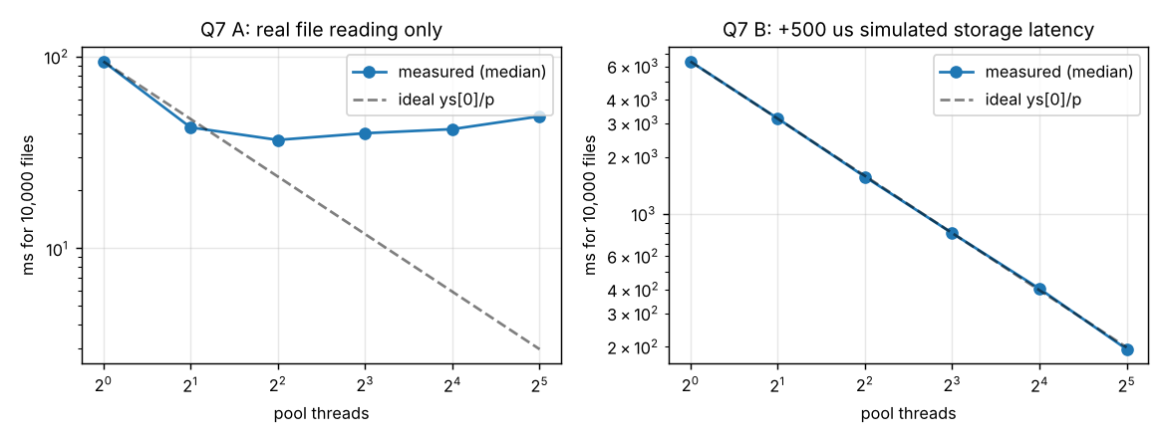
Figure Q7.2 – Total time for 10,000 files vs pool size (log–log, dashed = ideal speed-up)

Stage 4 – Defend the design (joint, 2 marks)

4.1 Recommended pool size, and why more threads did not always help
Recommendation: make the pool size a parameter; use 8 as the default, and about 32 for slow network storage – but find the exact value by measuring on the real storage. Evidence: (A) with fast local reads the time fell from 95 ms (1 thread) to 37 ms (4 threads, 2.6×) and then rose again – 40 ms at 8, 42 ms at 16, 49 ms at 32 – so more than about 4–8 threads brought nothing; (B) with 500 µs of waiting per file the speed-up was almost perfectly linear: 2.0× (2), 4.1× (4), 7.9× (8), 15.7× (16), 31.8× (32), because a waiting thread uses no CPU. A useful rule: threads ≈ cores × (1 + wait time / compute time). Here compute ≈ 4 µs per file and wait 500 µs, so the rule allows far more than 8 threads for slow storage, while for fast local reads wait ≈ 0 and the rule gives ≈ the number of cores.
Why more threads did not always help: (1) there is nothing left to overlap once the CPU or the disk is saturated – this machine has one core, so extra threads can only wait; (2) every extra thread adds context switches, scheduler work and contention on the shared queue and map (A: 49 ms at 32 threads against 37 ms at 4); (3) each thread costs memory (about 1 MB of reserved stack and ≈ 76 KB resident, Q4); (4) the storage device has its own limit on concurrent requests. Because the sandbox has one core, the 2×–2.6× gain in A comes from overlapping blocking system calls and the submission work, not from parallel computation – on a multi-core computer the numbers will differ and must be re-measured.

4.2 How the design guarantees a complete and correct summary
- Exactly one result per file: every path through ScoreFileTask.call() – success, each catch, the generic RuntimeException catch – ends in sink.put(fileName, result); the key is the file name, so a file cannot be recorded twice.
- Safety net: if a task fails in a way the task itself did not handle (a bug, an Error), Future.get() throws ExecutionException and the processor records an ERROR result with putIfAbsent – tested by fault injection.
- The summary is built only after all tasks have finished: the processor calls get() on every future (and shuts the pool down) before creating Summary, and Future.get() establishes a happens-before relation, so the main thread sees every result.
- Self-check: Summary.complete is true only if success + corrupt + missing + error == submitted; it was true in all 54 timed runs, the fault-injection run and the correctness runs.
- Correctness: the counts equal the hand calculation (15 files) and the generator's ground truth (10,000 files), for every pool size.

4.3 One remaining limitation
There is no time limit for a single file. A read that blocks forever (a network share that stops responding) occupies a worker thread permanently; if all p workers hang, the run never completes (future.get() has no timeout). A production version would use future.get(timeout) with cancel(true) and record such files as ERROR ("timed out"). Two lesser limitations: all results are held in memory (10,000 small records is fine, millions would need streaming), and duplicate file names in the index would collide on the map key – the complete check would flag that run as incomplete instead of silently succeeding.

Alternative Concept and Complexity Analysis – parallelStream() or one thread per file
Parallel streams: files.parallelStream().forEach(f -> new ScoreFileTask(f, sink, lat).call()) – no executor code, the work runs on the JVM-wide common ForkJoinPool, whose parallelism is about *cores − 1* (here 1), not a number we choose, and it is meant for CPU-bound work: blocking I/O inside it starves other parallel streams. Thread per file: new Thread(task).start() for each of the 10,000 files.
files.parallelStream().forEach(f -> new ScoreFileTask(f, sink, lat).call()); // alternative 1
for (Path f : files) { Thread t = new Thread(new FutureTask<>(new ScoreFileTask(f, sink, lat))); t.start(); } // alternative 2

Approach (10,000 files) | Total time | Threads and memory | Failure of one file
ExecutorService, p = 8, 500 µs latency | 804 ms (p = 32: 200 ms) | p threads: 8 × ≈ 76 KB resident (8 × 1 MB reserved) | Handled: one result per file; run continues (R1)
parallelStream(), no latency | 317 ms | common pool: 1 worker here (cores − 1) + caller; O(cores) threads | Handled only because the task converts failures; see next row
parallelStream(), 500 µs latency | 3,410 ms (executor with 8 threads: 804 ms) | same – cannot use more than the common pool's parallelism; blocking waits waste the few workers | same
parallelStream(), no per-element handling | aborted after 89 of 10,000 files, in 55 ms | same | The first corrupt file aborted the whole run; the other results are lost and no summary exists
One thread per file, 500 µs latency | 1,768 ms | peak 55 live threads (they finish quickly); resident +39.8 MB | Handled (same task), plus the cost below
One thread per file, slow storage (2 s per file) | 7,334 ms | peak 10,006 live threads; resident +267,812 KB (≈ 262 MB); reserved virtual +10,243,292 KB (≈ 9.8 GB) = 10,006 × 1 MB stack | Handled, but the process nearly exhausted memory/thread limits

$ java -cp out results.Alternatives parstream-naive data 0
mode = parstream-naive, files = 10000, simulated latency = 0 us, processors = 1, common pool parallelism = 1
whole run ABORTED after 89 of 10000 files were processed: java.lang.RuntimeException: score02521.txt: results.CorruptFileException: empty file
no summary can be produced; the other files' results are lost (not collected anywhere).
time until abort = 55 ms

Analysis. *Total time:* the executor needs about ⌈N/p⌉ × (wait + compute) = Θ(N/p) for p up to the useful limit (measured 804 ms at p = 8 for N = 10,000, 500 µs); parallel streams are limited by the common pool's parallelism *c* (≈ cores − 1, here 1), so Θ(N/c) – 3,410 ms; one thread per file is Θ(N/min(N, thread limit)) in theory, but only as fast as threads can be created (≈ 1.8 s for 10,000 here: ≈ 177 µs of creation and scheduling per file, while the pool needed 0.6 µs per task in Q4). *Memory = threads × stack size:* the executor: p × 1 MB = 8 MB reserved; the common pool: c × 1 MB; one thread per file: N × 1 MB = about 9.8 GB reserved (measured 10.2 GB) and ≈ 262 MB resident – O(N) memory instead of O(p), and the JVM can fail with OutOfMemoryError: unable to create native thread on a computer with less memory or a lower process limit. *Failure handling:* in a parallel stream an exception that escapes the lambda terminates the whole pipeline (89 files processed, no summary), so it is correct only if every element handles its own failures – the same discipline as the task of the executor design; with raw threads an uncaught exception ends only that thread, and its result is silently missing unless the task records it. Conclusion: the fixed pool is retained: bounded threads and memory, a tunable degree of parallelism for I/O-bound work, explicit Future-based failure handling and a guaranteed complete summary.

Conclusion
Exceptions were classified, ordered and chained so that no failure information is lost (Q1, Q2); resource safety was demonstrated with breakpoints, counted handles and try-with-resources (Q3); thread behaviour was observed, not assumed, over 24 recorded runs (Q4); the race condition, the deadlock and the producer–consumer defects were each reproduced, explained and fixed or prevented (Q5, Q6); and a fault-tolerant concurrent processor was designed from requirements, implemented, tested with injected faults and defended with measurements (Q7). Wherever an experiment could not show an effect on the single-core test machine, that is stated and the way it was made visible is described. The alternative concepts were implemented or measured, and in each case the chosen design was retained for a stated, evidence-based reason.

